Food and Climate Change
– How can we feed the growing world population without increasing global warming?

This flowchart describes the main cause and consequences of global warming.

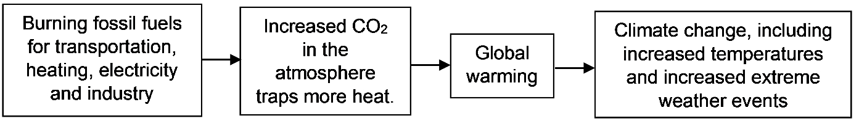

Agriculture has been an important additional cause of global warming. In this activity, you will learn how agriculture increases three major greenhouse (heat-trapping) gases in the atmosphere. These greenhouse gases are carbon dioxide (CO₂), methane (CH₄), and nitrous oxide (N₂O). At the end of this activity, you will research strategies to reduce agriculture’s contributions to global warming, which leads to climate change.

How does agriculture increase carbon dioxide (CO₂) in the atmosphere?
This figure shows a simple agricultural carbon cycle. Carbon atoms cycle between CO₂ in the air and organic molecules in the grass and cow. Cellular respiration and photosynthesis play key roles in this carbon cycle.  1a. To describe cellular respiration and photosynthesis, choose the best matches from the bottom list.  Cellular respiration ___ ___ ___  Photosynthesis ___ ___ ___  a. produces carbon dioxide (CO₂)  b. uses carbon dioxide (CO₂) | 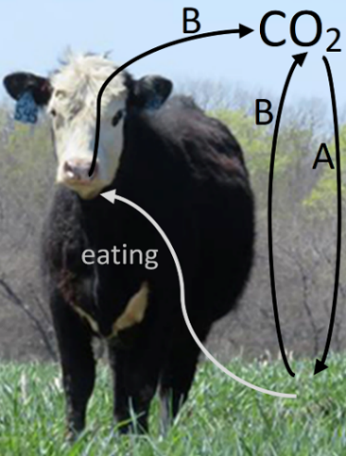
c. depends on uptake of CO₂ (represented by A arrow)
d. results in B arrows
e. produces ATP, which provides the energy for many cellular processes
f. produces sugars, which provide input for cellular respiration

1b. This agricultural carbon cycle is roughly balanced between cellular respiration (which ______________ CO₂) and photosynthesis (which _______________ CO₂).
(produces / uses) (produces / uses)

Burning fossil fuels in farm equipment is one way that agriculture contributes to increased CO₂ in the atmosphere. This is not balanced by the formation of fossil fuels, which takes millions of years. | 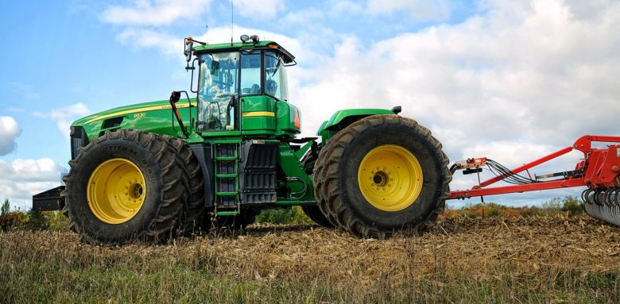

2a. Workers cut down trees and burn them to clear land for agriculture. Increased agricultural land is needed to produce food for the growing world population. Explain why burning trees increases CO₂ levels in the atmosphere.

2b. One way to reduce CO₂ levels in the atmosphere is to grow forests, so the total mass of trees on earth increases. How would growing more trees reduce the amount of CO₂ in the atmosphere?

3a. A cow weighs much less than the weight of all the food that the cow has ever eaten. What happened to the extra weight of the food that the cow ate? For example, where did the carbon atoms in the food molecules go?

3b. Why does it take more land to feed a meat eater than to feed a vegetarian? (Hint: Think about the question 3a.) | 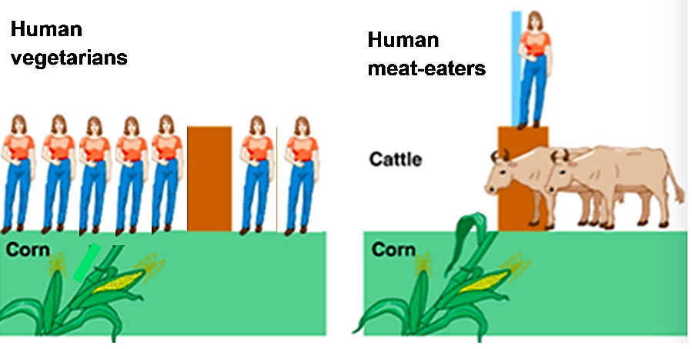

4a. Which would result in more increase in CO₂ in the atmosphere?
- growing enough food to feed someone who eats mainly food derived from plants
- growing enough food to feed someone who eats mainly meat

4b. Explain your reasoning.

How does agriculture increase methane (CH₄) in the atmosphere?

Animals cannot make enzymes that digest cellulose, a molecule that is abundant in grass and hay. Microorganisms that can digest cellulose live in the extra chambers of the stomachs of cows and sheep. These microorganisms produce:  - molecules that the cow or sheep can use  - methane (CH₄), which the cow or sheep releases into the air. | 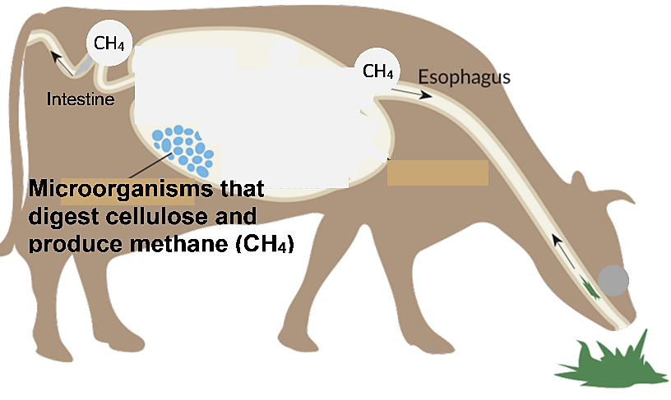
Pigs and chickens do not have extra chambers in their stomachs, so pigs and chickens have many fewer of these microorganisms, compared to cows and sheep. Therefore, raising pigs or chickens produces much less methane than raising cows or sheep.

5. Explain why more greenhouse gases are released during the production of a serving of beef, compared to the production of the same amount of chicken meat.

Rice is often grown in flooded fields. This prevents oxygen from reaching the soil. When microorganisms in the soil produce ATP without oxygen, some of them produce methane.
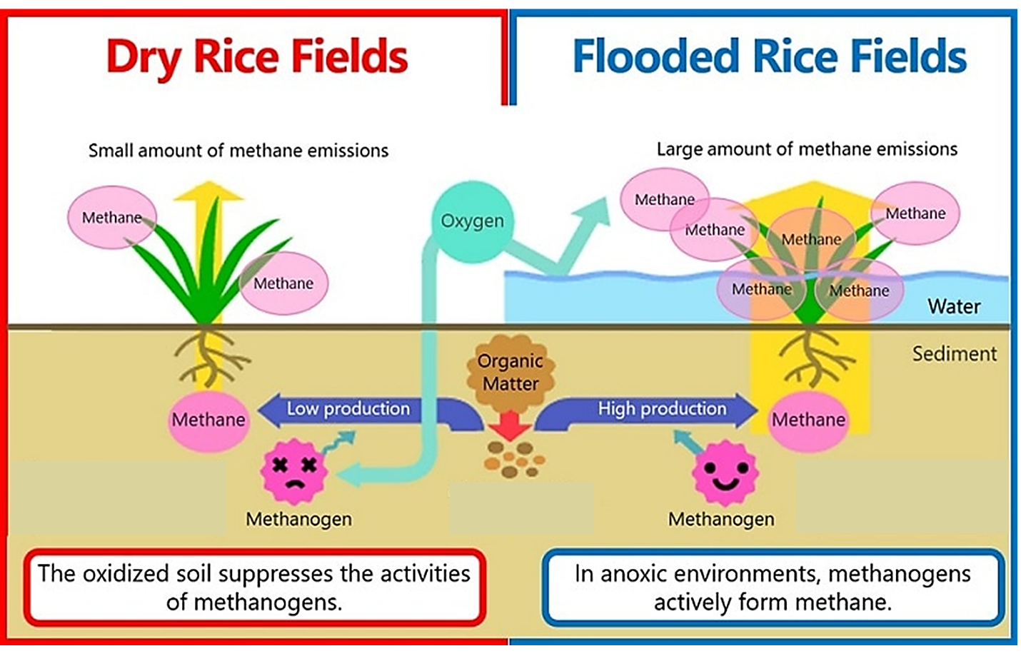
6. Explain why more greenhouse gases are released when rice is grown in flooded fields, compared to growing the same amount of rice in dry fields.

How does agriculture increase nitrous oxide (N₂O) in the atmosphere?
7. Why do plants need nitrogen atoms? What kinds of molecules in plants and other organisms contain nitrogen atoms?

Plants depend on nitrogen-fixing bacteria to convert the abundant N₂ in the atmosphere to ions that plants can use. Some plants have special structures on their roots to house nitrogen-fixing rhizobium bacteria.
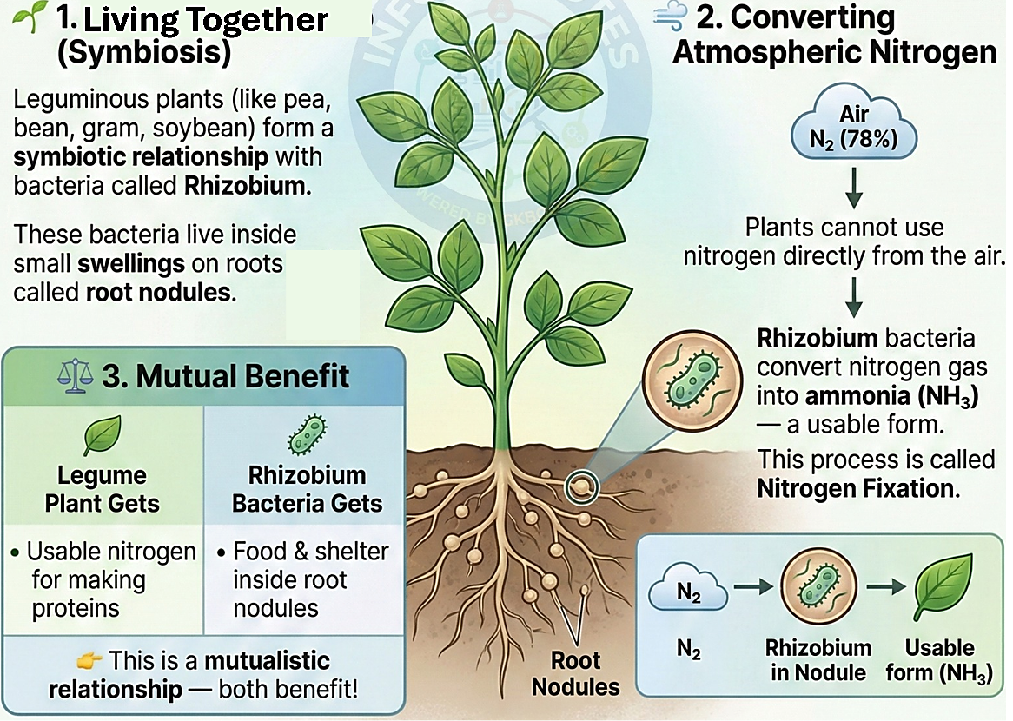
8. Why is the relationship between a legume plant and nitrogen-fixing rhizobium bacteria called a “mutualistic symbiosis”?

Other plants do not have symbiotic nitrogen-fixing bacteria. To increase growth of these plants, farmers spread nitrogen-containing fertilizer or manure on their fields. Excessive fertilizer or manure can result in more nitrogen than crop plants can use. Some of the excess nitrogen is converted by microorganisms to N₂O, which is released to the atmosphere.

9. If farmers spread excess fertilizer on their fields, how does this contribute to global warming and climate change? (Hint: N₂O is a greenhouse gas, but N₂ is not.)

10a. A cow consumes roughly 25 pounds of feed for every pound of meat the cow produces. Which would result in more N₂O released to the atmosphere?
- producing a pound of beef b. producing a pound of beans
10b. Explain your reasoning.

Total Greenhouse Gases Released during the Production of Different Types of Food

The figure below shows the total amount of greenhouse gases released to the atmosphere during the production of an amount of each food that contains 100 g of protein.

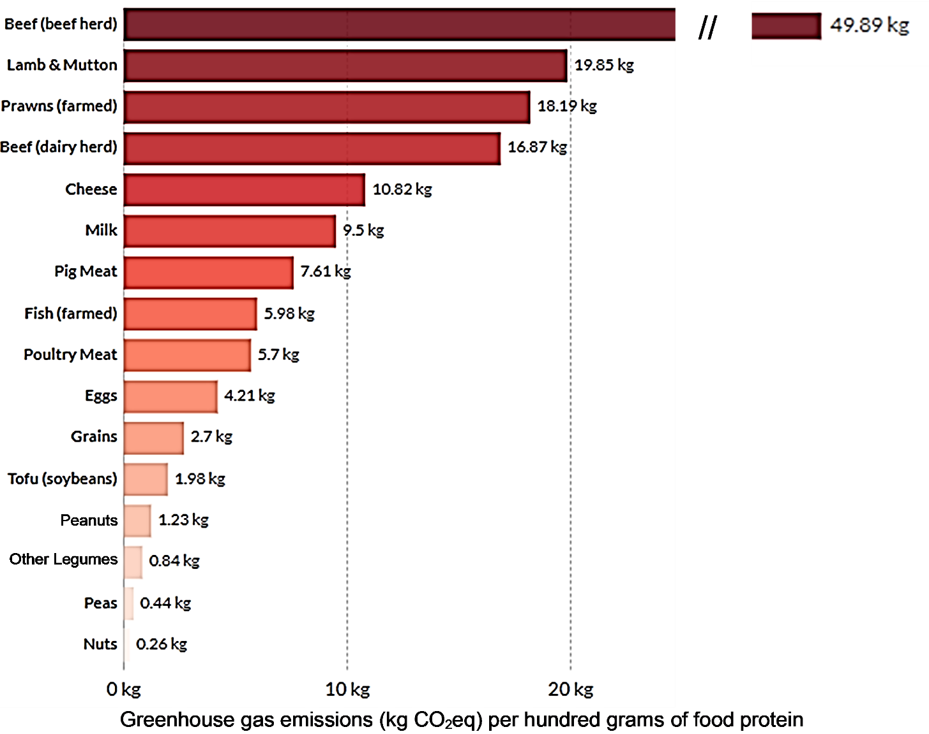
The amount of greenhouse gases is measured in kilograms of CO₂ equivalents (kg CO₂eq). This measure gives greater weights to a kilogram of methane (CH₄) or nitrous oxide (N₂O), because each kilogram of these greenhouse gases contributes more to global warming than a kilogram of CO₂.

11a. Based on the information in this figure, which results in more greenhouse gases released during the production of 100 g of food protein? foods from animals ___ foods from plants ___

11b. Explain the reasons for this difference between foods from animals vs. foods from plants.

12. Roughly a quarter of the food produced globally gets wasted. For example, some food is thrown away when it spoils, and some food is eaten by rodents or insects. Explain how food waste contributes to increased greenhouse gases in the atmosphere.

How can we feed the growing world population without increasing global warming?

Globally, agriculture and clearing forests for agriculture result in roughly 20-30% of greenhouse gas emissions. Thus, these contributions to greenhouse gas emissions must be reduced as part of any approach that could avoid serious damage due to global warming and climate change. In contrast, the amount of greenhouse gases released during food production has been increasing because:
- the number of people in the world is increasing and
- meat consumption per capita has been increasing, especially in low-income countries (although meat consumption in low-income countries is still much less than in the US).

13. Propose several strategies to reduce the amount of greenhouse gases that will be released by food production in the future. (Hint: To get ideas for possible strategies, you can review the previous pages of this learning activity and the Reliable Relevant Sources listed on pages 7-8.)

14. The first column of this table suggests two criteria to use when evaluating a proposed strategy to reduce greenhouse gas emissions during food production. Answer the questions in the second column of the table.
A good proposed strategy should: | Do you agree or disagree with each proposed criterion?  If you disagree, suggest a better version of the criterion.
be feasible (e.g., should not use
too many scarce resources)
reduce the amount of food available
in low-income countries

15. Prepare a brief report that describes and evaluates a proposed strategy to reduce the amounts of greenhouse gases released during future food production. Use the information from the Reliable Relevant Sources listed on pages 7-8 to:
- improve your proposed strategy (e.g., by making it more specific)
- evaluate the advantages and disadvantages of your proposed strategy (e.g., evaluate how well the proposed strategy would meet the criteria developed in response to question 14)
- describe any additional information that you would want in order to better evaluate your proposed strategy.

Reliable Relevant Sources

Healthy eating can reduce greenhouse gas emissions.
- Healthy Diet May Reduce Gas; Greenhouse Gas, That Is (http://www.climatecentral.org/news/diet-may-reduce-gas-greenhouse-gas-that-is-20160)
- What Humanity Should Eat to Stay Healthy and Save the Planet
(https://www.nature.com/articles/d41586-021-03565-5)
- When Spending Less Delivers More Climate-Friendly Nutrition
(https://now.tufts.edu/2025/12/10/when-spending-less-delivers-more-climate-friendlynutrition)
d. Environmental benefits of alternative proteins (https://gfi.org/resource/environmental-impacts-of-alternative-proteins/)
e. The diet that helps fight climate change (https://www.youtube.com/watch?v=nUnJQWO4YJY)
f. How to eat well and within Earth’s limits (https://www.nature.com/articles/d41586-026-00236-1)
g. Tax high carbon food, sugar for climate and health gains – study
(http://www.climatechangenews.com/2016/02/03/the-bitter-taste-of-taxing-your-steakscarbon-footprint/)

Improving Agricultural Methods to Reduce Greenhouse Gas Emissions a. Farmers Lead the Way in Reducing Greenhouse Gas Emissions
(https://www.youtube.com/watch?v=k4HFjckmfsE)
- Boosting milk-production efficiency can reduce cow methane-emission intensity (https://news.psu.edu/story/383607/2015/12/07/campus-life/boosting-milk-productionefficiency-can-reduce-cow-methane)
- Cutting Cattle Methane through Feed Additives: Lessons from Early Adoption and the Road Ahead (https://www.wri.org/technical-perspective/cattle-methane-inhibitors-early-adoption-next-steps)
- How to stop rice fields producing so much methane (https://www.dw.com/en/how-to-stoprice-fields-producing-so-much-methane/a-65331307)
- Management of Nitrogen Fertilizer to Reduce Nitrous Oxide (N₂O) Emissions from Field
Crops (https://www.canr.msu.edu/resources/management_of_nitrogen_fertilizer_to_reduce_nitrous_oxide_emissions_from_fi)
f. Understanding the Land-Based Economy: Agricultural Greenhouse Gas Emissions 101 (https://www.terrascope.com/blog/understanding-the-land-based-economy-agricultural-greenhouse-gas-emissions-101)
g. Reduce Greenhouse Gas Emissions from Agricultural Production (Synthesis) (https://research.wri.org/wrr-food/course/reduce-greenhouse-gas-emissions-agricultural-production-synthesis)

Reducing Food Loss and Waste to Reduce Greenhouse Gases
- 10 Ways to Cut Global Food Loss and Waste (https://www.wri.org/insights/10-ways-cutglobal-food-loss-and-waste)
- Reduce Food Waste to Reduce Climate Change (https://www.youtube.com/watch?v=brirKMT-WOY)
- The Global Benefits of Reducing Food Loss and Waste and How to Do It (https://www.wri.org/insights/reducing-food-loss-and-food-waste)

Using insects as food or feed for farm animals can reduce greenhouse gas emissions.
- Five reasons we should all be eating insects (https://qz.com/84127/five-reasons-we-shouldall-be-eating-insects)
- 5 reasons why eating insects could reduce climate change
(https://www.weforum.org/stories/2022/02/how-insects-positively-impact-climatechange/)
- Plant Ecologist: We Should Be Eating More Insects and Using Their Waste To Grow Crops (https://scitechdaily.com/plant-ecologist-we-should-be-eating-more-insects-and-usingtheir-waste-to-grow-crops/)

Reducing Population Growth to Reduce the Amount of Food Needed
- Climate Curious: How much does population growth contribute to climate change? (https://www.mprnews.org/story/2019/12/11/climate-curious-how-much-doespopulation-growth-contribute-to-climate-change)
- The Connections between Population and Climate Change
(https://populationconnection.org/resources/population-and-climate/)
- Population Matters – Solutions (https://populationmatters.org/solutions)

By Dr. Ingrid Waldron, Biology Department, University of Pennsylvania. © 2026. This Student Handout and Teacher Notes (with instructional suggestions and background information) are available at https://serendipstudio.org/exchange/bioactivities/FoodClimateChange.

