Teacher Notes for “Food and Climate Change
– How can we feed the growing world population without increasing global warming?”

In this analysis and discussion activity, students learn how food production contributes to the release of three greenhouse gases – carbon dioxide (CO₂), methane (CH₄), and nitrous oxide (N₂O). Students use biological concepts (e.g. trophic pyramids) to interpret data concerning the very different amounts of greenhouse gases released during the production of specific types of food. Finally, students propose, research, and evaluate strategies to reduce the amount of greenhouse gases that will be released during future production of food for the world’s growing population.

Before beginning this activity, students should be familiar with the role of greenhouse gases in global warming and climate change. Students should also be familiar with biological molecules, photosynthesis, and cellular respiration. I recommend the following learning activities to help your students prepare for this activity:
- “Introduction to Global Warming and Climate Change” (https://serendipstudio.org/exchange/bioactivities/IntroGlobalWarming)
- “Carbon Cycles and Energy Flow through Ecosystems and the Biosphere” (https://serendipstudio.org/exchange/bioactivities/carboncycle)
- “Trophic Pyramids” (https://serendipstudio.org/exchange/bioactivities/trophicpyr)

Table of Contents
Learning Goals – pages 1-2
Instructional Suggestions and Background Information
General and Introduction – pages 2-4
How does agriculture increase carbon dioxide (CO₂) in the atmosphere? – pages 4-6
How does agriculture increase methane (CH₄) in the atmosphere? – pages 6-7
How does agriculture increase nitrous oxide (N₂O) in the atmosphere? – pages 7-9
Total Greenhouse Gases Released during the Production of Different Types of Food – pages 10-13
How can we feed the growing world population without increasing global warming?
– Instructional Suggestions – pages 13-15
– Background Information – pages 15-18
Sources for Student Handout Figures – pages 18-19

Learning Goals
In accord with the Next Generation Science Standards:
      - Students will increase their understanding of Disciplinary Core Ideas:
- LS2.B: “Plants or algae form the lowest level of the food web. At each link upward in a food web, only a small fraction of the matter consumed at the lower level is transferred upward, to produce growth and release energy in cellular respiration at the higher level. … Some matter reacts to release energy for life functions, some matter is stored in newly made structures, and much is discarded. The chemical elements that make up the molecules of organisms pass through food webs and into and out of the atmosphere and soil, and they are combined and recombined in different ways. … Photosynthesis and cellular respiration are important components of the carbon cycle, in which carbon is exchanged among the biosphere, atmosphere, oceans and geosphere through chemical, physical, geological, and biological processes”
- ESS3.D: “Human activities, such as the release of greenhouse gases from burning fossil fuels, are major factors in the current rise in Earth’s mean surface temperature (global warming). Reducing the level of climate change… depends on the understanding of climate science, engineering capabilities, and other kinds of knowledge, such as understanding of human behavior and on applying that knowledge wisely in decisions and activities.”
      - This activity helps to prepare students for Performance Expectations:
- HS-LS2-4. “Use mathematical representations to support claims for the cycling of matter and flow of energy among organisms in an ecosystem.”
- HS-LS2-5. “Develop a model to illustrate the role of photosynthesis and cellular respiration in the cycling of carbon among the biosphere, atmosphere, hydrosphere, and geosphere.”
- HS-LS2–7. “Design, evaluate, and refine a solution for reducing the impacts of human activities on the environment and biodiversity.”
- HS-ETS1-1. “Analyze a major global challenge to specify qualitative and quantitative criteria and constraints for solutions that account for societal needs and wants.”
      - Students will engage in several Science and Engineering Practices.
- Constructing Explanations and Designing Solutions: “Apply scientific ideas, principles and/or evidence to provide an explanation of phenomena and solve design problems, taking into account possible unanticipated effects.” “Design, evaluate, and/or refine a solution to a complex real-world problem, based on scientific knowledge, student-generated sources of evidence, prioritized criteria, and trade-off considerations.”
- Engaging in Argument from Evidence: “Evaluate competing design solutions to a real-world problem based on scientific ideas and principles, empirical evidence, and/or logical arguments regarding relevant factors (e.g. economic, societal, environmental, ethical considerations).”
- Obtaining, Evaluating and Communicating Information: “Critically read scientific literature adapted for classroom use to determine the central ideas or conclusions and/or to obtain scientific and/or technical information to summarize complex evidence, concepts, processes, or information presented in a text by paraphrasing them in simpler but still accurate terms.”
      - This activity provides the opportunity to discuss the Crosscutting Concepts:
- Cause and Effect: Mechanism and Prediction: “Cause and effect relationships can be suggested and predicted for complex natural and human designed systems by examining what is known about smaller scale mechanisms within the system.”
- Scale, Proportion and Quantity: “The significance of a phenomenon is dependent on the scale, proportion, and quantity at which it occurs.”

Background Information and Instructional Suggestions
To maximize student participation and learning, I suggest that you have your students work in pairs to complete each group of related questions and then have a class discussion after each group of questions. In each discussion, you can probe student thinking and help them develop a sound understanding of the concepts and information covered before moving on to the next group of related questions.

You may want to revise the Word document to prepare a version of the Student Handout that will be more suitable for your students. If you use the Word document, please check the format by viewing the PDF.

A key is available upon request to Ingrid Waldron (iwaldron@upenn.edu). The following paragraphs provide additional instructional suggestions and background information – some for inclusion in your class discussions and some to provide you with relevant background that may be useful for your understanding and/or for responding to student questions.

The two related driving questions for this activity are:
- How does agriculture contribute to increased greenhouse gases in the atmosphere?
- How can we feed the growing world population without increasing global warming and climate change?

The top of page 1 of the Student Handout briefly places agriculture in the context of aspects of global warming that may be more familiar to your students. Estimates of the contribution of food production to total greenhouse gas emissions vary, due to differences in methods such as differences in which activities or geographic regions were included in the estimates. For example, the contribution of food production to total greenhouse gas emissions is estimated to be ~10% for the US vs. ~20-30% worldwide (see figures below; https://www.epa.gov/ghgemissions/agriculture-sector-emissions; https://ourworldindata.org/greenhouse-gas-emissions-food). If you introduce these estimates, you may want to ask your students to suggest a likely cause of the difference between the estimates for the US vs. the world. Hopefully, your students will recognize the importance of thinking about the denominator as well as the numerator used to calculate these percents. The contribution of food production is a smaller part of a bigger total in the US, because we produce so much CO₂ through our high use of fossil fuels for transportation, manufacturing, generation of electricity, and heating (https://www.epa.gov/ghgemissions/sources-greenhouse-gas-emissions#agriculture).

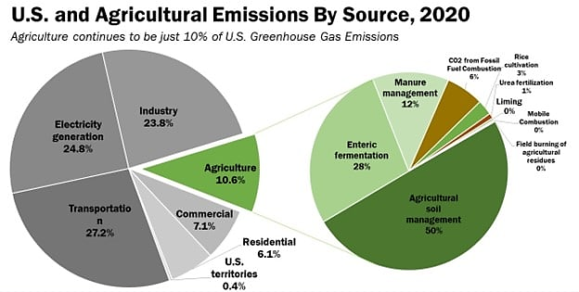
(Agricultural soil management includes e.g. fertilizers resulting in N₂O emissions;
enteric fermentation results in methane emissions;
https://www.northernag.net/americas-farmers-are-reducing-greenhouse-gas-emissions/)
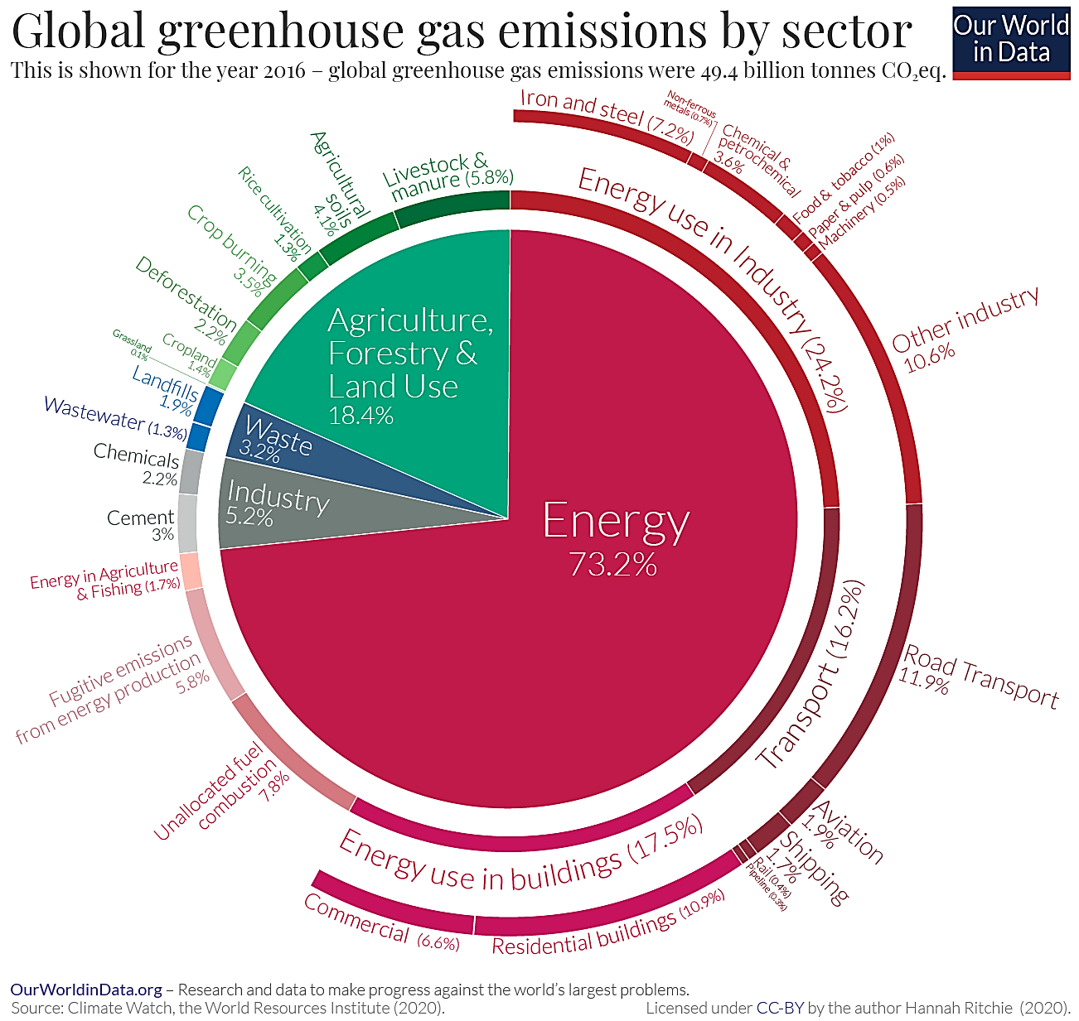
(https://ourworldindata.org/ghg-emissions-by-sector)

How does agriculture increase carbon dioxide (CO₂) in the atmosphere?
Question 1 reviews the role of cellular respiration and photosynthesis in the carbon cycle (https://serendipstudio.org/exchange/bioactivities/carboncycle). The rest of page 1 introduces burning fossil fuels in farm equipment as one major way that agriculture contributes to increased carbon dioxide in the atmosphere. The figure below may be used to reinforce these concepts.

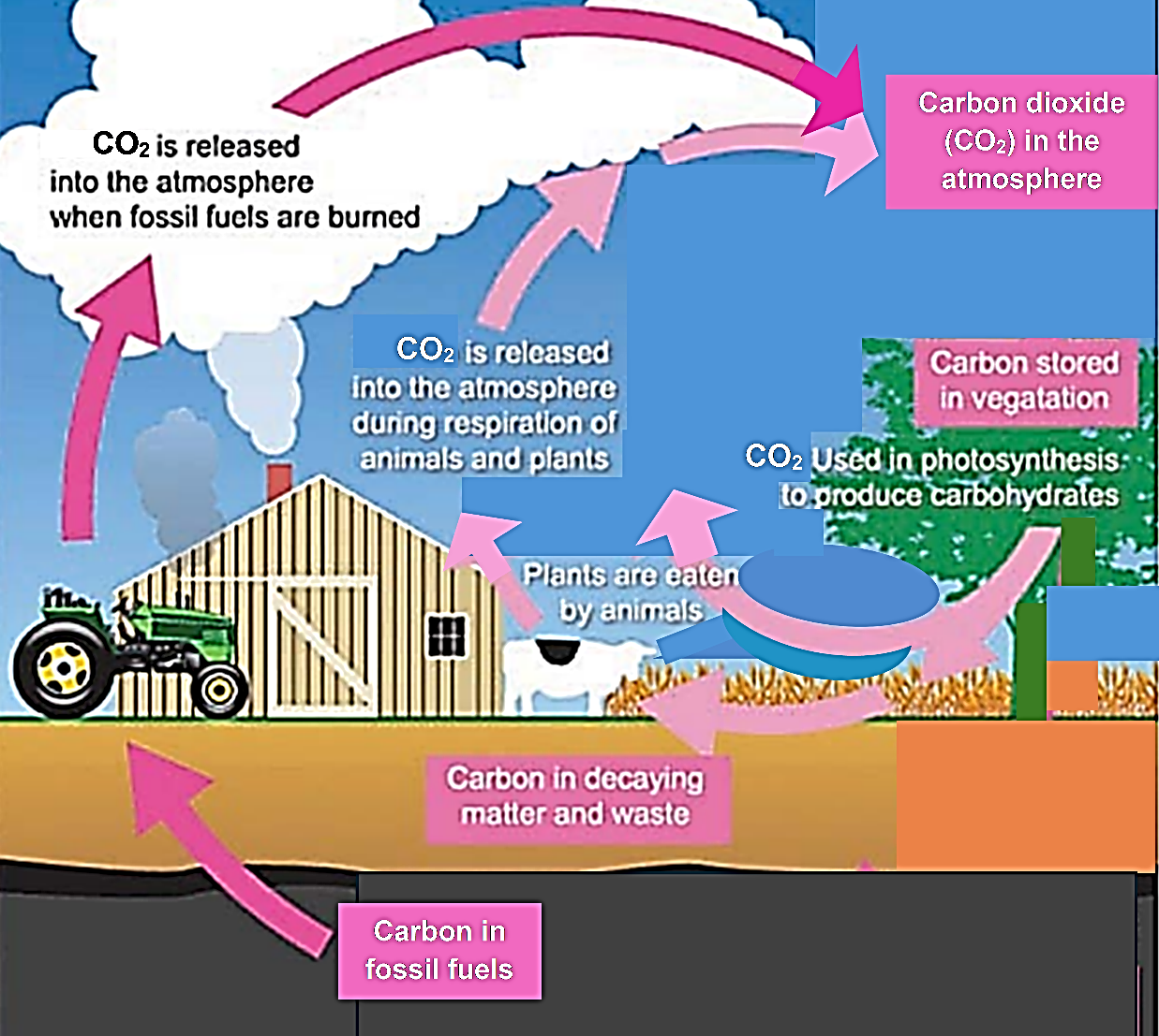

The lighter arrows in this figure show an agricultural carbon cycle where cellular respiration (which produces CO₂) is roughly balanced by photosynthesis (which uses CO₂). The darker arrows in this figure show that burning fossil fuels increases the carbon dioxide (CO₂) in the atmosphere.
(Modified from https://cdn.dal.ca/content/dam/dalhousie/pdf/faculty/agriculture/oacc/en/tcog/TCOG_2012_Carbon_Footprint.pdf)
Class discussion of student answers to question 2a will help students understand why cutting down and burning trees to clear land for agriculture is a significant contributor to increased CO₂ in the atmosphere. (If the trees are not burned, but instead are left to rot, the decomposers that rot the trees will release CO₂ to the atmosphere, although more slowly than burning.)

Answering question 2b will reinforce student understanding that growing trees absorb CO₂ from the atmosphere and use the carbon from CO₂ to create sugars and other organic molecules that are incorporated into the structure of trees. Thus, carbon is stored in the increased biomass of the trees and CO₂ is removed from the atmosphere.

As you discuss question 3a, you may want to mention that the average American consumes almost 2000 pounds of food each year; clearly, we do not gain nearly that much weight each year (https://serendipstudio.org/exchange/bioactivities/foodenergy). Beverages and some foods (e.g., many fruits and vegetables) contain a lot of H₂O. Some H₂O is retained to replace H₂O lost in sweat, exhaled air, and excretion of waste molecules; any surplus water is excreted in the urine. During class discussion of student answers to this question, you will probably want to include the following points.
- Cellular respiration converts many of the molecules in food to CO₂ and H₂O. CO₂ leaves the body via exhalation. Much of the H₂O is excreted in the urine.
- Some food molecules are not absorbed from the digestive system and leave the body in feces.

Questions 3-4 provide the opportunity to discuss why eating at a higher trophic level requires more resources and produces more greenhouse gases. If your students are unfamiliar with trophic pyramids, you will probably need to explain the figure in question 3b. Alternatively, you can precede this activity with learning activities about trophic pyramids (e.g., “Trophic Pyramids” (https://serendipstudio.org/exchange/bioactivities/trophicpyr) or “Food Webs, Energy Flow, Carbon Cycle, and Trophic Pyramids” (https://serendipstudio.org/sci_edu/waldron/#ecolfoodweb)).

How does agriculture increase methane (CH₄) in the atmosphere?
Methane is a relatively short-lived greenhouse gas, lasting roughly 12 years in the atmosphere, in contrast to carbon dioxide, which lasts roughly 200 years. However, over a 20-year period, methane is roughly 80 times more potent as a greenhouse gas than carbon dioxide.

Cows, like other animals, cannot produce enzymes that digest cellulose. The microorganisms in the rumen and reticulum of a cow digest cellulose to produce fatty acids which are absorbed into the cow’s blood (see figure below). These fatty acids are a primary source of energy for the cow. The microbes of the rumen and reticulum pass to the omasum and thence to the abomasum and intestines where the microbes are killed and digested; this provides the main source of amino acids for cows. As explained in the Student Handout, the microorganisms in a cow’s rumen and reticulum produce methane. Researchers are working to develop feed additives that can reduce methane emissions from cows (https://www.wri.org/technical-perspective/cattle-methane-inhibitors-early-adoption-next-steps).

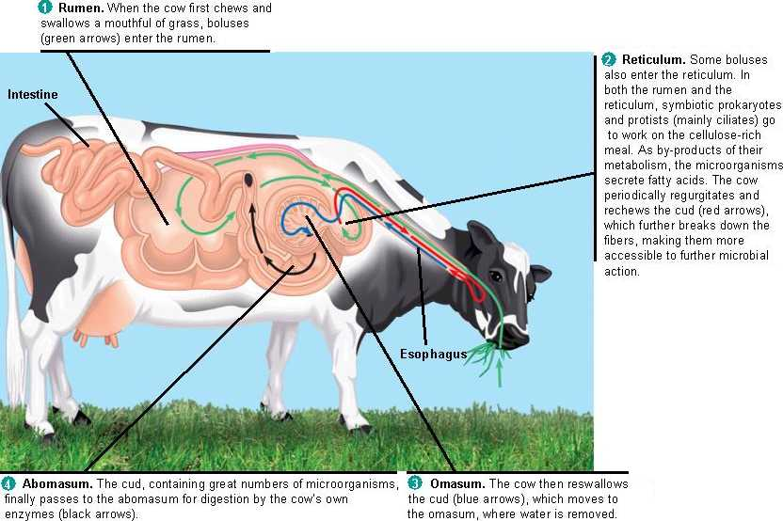
(http://www.zo.utexas.edu/faculty/sjasper/images/ruminantdigestion.jpg)

Ruminant is the name given to animals that have multiple stomachs to house the microorganisms that digest cellulose. Of the three main types of animals raised for meat in the US (cows, pigs and chickens), only cows are ruminants. Other ruminants include sheep (lambs), goats and camels. For the comparison between beef and chicken in question 5, you may want to discuss
that cows are less efficient than chickens at converting feed to meat for human consumption, so more feed production is required for each kilogram of beef (see figure). | 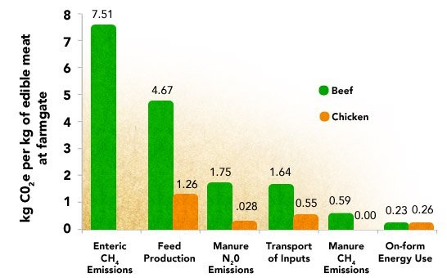
(https://www.ewg.org/meateatersguide/a-meat-eaters-guide-to-climate-change-health-what-you-eat-matters/climate-and-environmental-impacts/)

If you want your students to compare digestion in humans vs. cows, you could use the following question.
5b. Explain the reasons for both of the following differences between cows and humans:
- Cows can live on a diet of grass and hay, but humans cannot.
- A cow releases much more methane into the atmosphere than a human.

Rice is planted in flooded fields to control weeds; rice can grow in water, but most common weeds cannot (https://www.youtube.com/watch?v=5fx3s9rdxkk). When fields are flooded, little oxygen diffuses to the soil, which creates an anoxic environment where methanogens can flourish. Methanogens use organic compounds from the roots of rice plants to produce ATP by a process that generates methane (https://pubmed.ncbi.nlm.nih.gov/29990451/). Methods to reduce this source of methane are discussed in (https://www.dw.com/en/how-to-stop-rice-fields-producing-so-much-methane/a-65331307; https://files.wri.org/d8/s3fs-public/wetting-drying-reducing-greenhouse-gas-emissions-saving-water-rice-production.pdf).

How does agriculture increase nitrous oxide (N₂O) in the atmosphere?
Nitrous oxide lasts for roughly 115 years in the atmosphere. On a per weight basis, nitrous oxide is roughly 300 times more potent as a greenhouse gas than carbon dioxide.

When you discuss question 7 with your students, you may want to use the figures below to remind your students of the chemical structures of amino acids, proteins, nucleotides and nucleic acids. You may also want to ask your students how animals get nitrogen (from amino acids in their food).
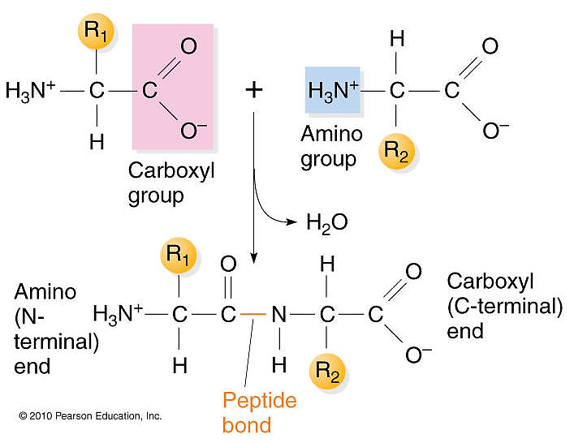
(https://www.mun.ca/biology/scarr/iGen3_06-03_Figure-Lsmc.jpg)

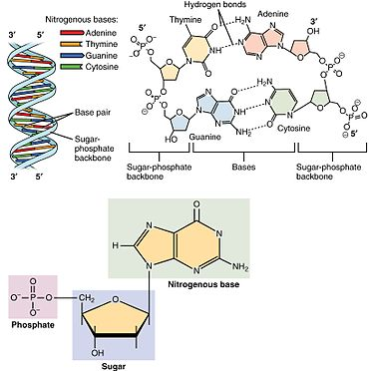
(https://upload.wikimedia.org/wikipedia/commons/thumb/d/d3/0322_DNA_Nucleotides.jpg/370px-0322_DNA_Nucleotides.jpg)

As shown in the figure on page 4 of the Student Handout and discussed in student answers to question 8, legumes are a good example of a mutualistic symbiosis. A more precise definition of symbiosis is a close and long-term interaction between two different species. Legumes also illustrate mutualism, since the plants benefit from the supply of NH₄⁺ and the bacteria benefit from a supply of nutrients that they use to produce ATP (https://www.biology-pages.info/N/NitrogenFixation.html). (A mutualistic symbiosis is also illustrated by the interactions between a cow and the microorganisms in the cow’s rumen and reticulum.) When legumes are plowed under, they can result in nitrous oxide emissions, but the nitrous oxide emissions are much lower than in a typical fertilized field.
This figure shows the roles of different types of bacteria in the nitrogen cycle.

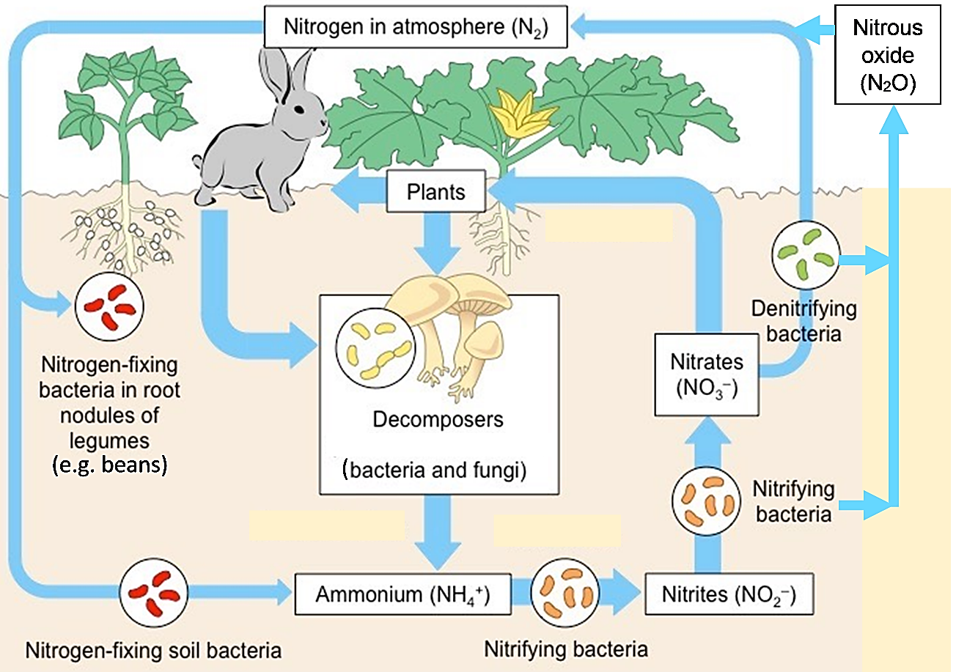

(Figure modified from https://www.bio.miami.edu/dana/330/330S23_1.html )

A comparison between the nitrogen cycle and the carbon cycle reveals a major difference – plants can take up carbon from the CO₂ in the air, but they cannot take up nitrogen from the abundant N₂ in the air. Instead, nitrogen-fixing bacteria use N₂ to make ammonium (NH₄⁺) and other bacteria convert ammonium to nitrate (NO₃⁻). Plants absorb NO₃⁻ (or, in some cases, NH₄⁺) from the soil. Bacterial metabolism of nitrogen compounds is complex and variable in different environments.

Nitrogen from nitrogen-fixing soil bacteria and decomposers is often a limiting resource for agricultural crop growth. This explains why farmers often use fertilizers that contain NH₄⁺ or NO₃⁻. Excess NO₃⁻ results in two environmental problems.
- The amount of NO₃⁻ that is converted to the greenhouse gas N₂O rises steeply with increasing soil concentrations of NO₃⁻.
- NO₃⁻ tends to dissolve in water that drains out of the soil, often resulting in eutrophication of nearby streams and lakes.
To avoid these problems, farmers should only apply as much fertilizer as the crop plants can use in the near future, and they should apply the fertilizer as close as possible to the roots of the crop plants (http://msue.anr.msu.edu/resources/management_of_nitrogen_fertilizer_to_reduce_nitrous_oxide_emissions_from_fi).

Total Greenhouse Gases Released during the Production of Different Types of Food
Scientists have estimated the global warming potential of one ton of methane (CH₄) or nitrous oxide (N₂O) over a 100-year period, relative to the global warming potential of one ton of CO₂. The relative global warming potential of methane is 28-36 and the relative global warming potential of nitrous oxide is 265-298 (https://www.epa.gov/ghgemissions/understanding-global-warming-potentials). These values are used to calculate total greenhouse gas emissions in kg CO₂e or CO₂eq (kilograms of CO₂ equivalent).

The two figures below show that the atmospheric concentrations of all three greenhouse gases have increased substantially during the twentieth and twenty-first centuries.
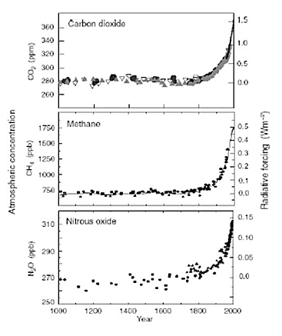
(https://www.thepoultrysite.com/articles/global-warming-how-does-it-relate-to-poultry-1)
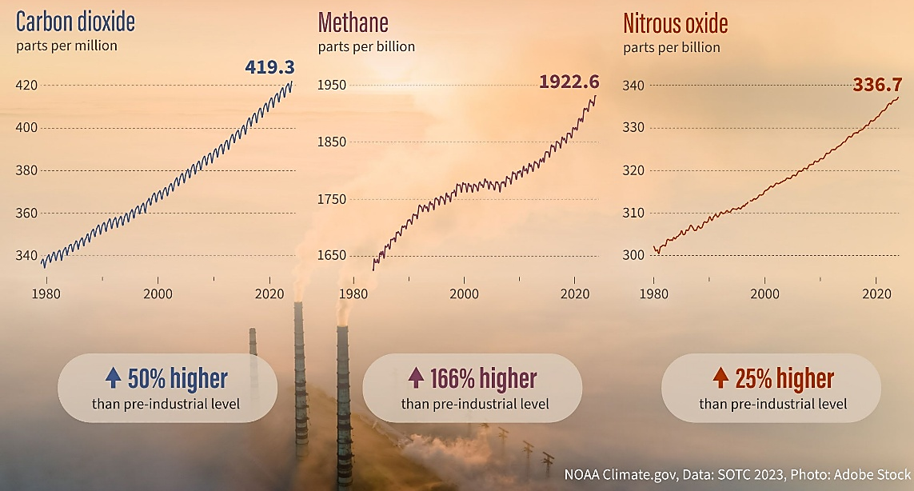
(https://cires.colorado.edu/news/international-report-confirms-record-high-greenhouse-gases-global-temperatures-and-ocean-heat)
The figure on page 5 of the Student Handout shows the greenhouse gas emissions per 100 g of protein in different types of food. The figure below shows total greenhouse gas emissions per thousand kilocalories in different types of food. In both figures, the rate of greenhouse gas emissions for beef from dairy cows (44% of the world’s beef) is much lower than the rate of greenhouse gas emissions for beef from beef herds; the reason why is that dairy cows produce both milk and beef, thus increasing the food yield per kilogram CO₂e emitted. As would be expected, the rate of greenhouse gas production per kilocalorie is substantially higher for rice than for wheat, rye and maize (corn).

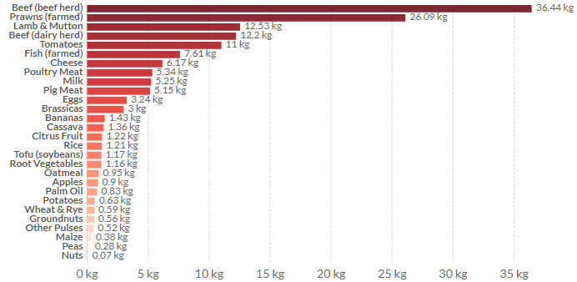
kilograms CO₂e
(https://ourworldindata.org/environmental-impacts-of-food?country=#carbon-footprint-of-food-products)

The figure below shows the breakdown of greenhouse gas emissions across the supply chain (i.e., land-use changes, on-farm emissions, animal feed, processing, transport, retail and packaging).
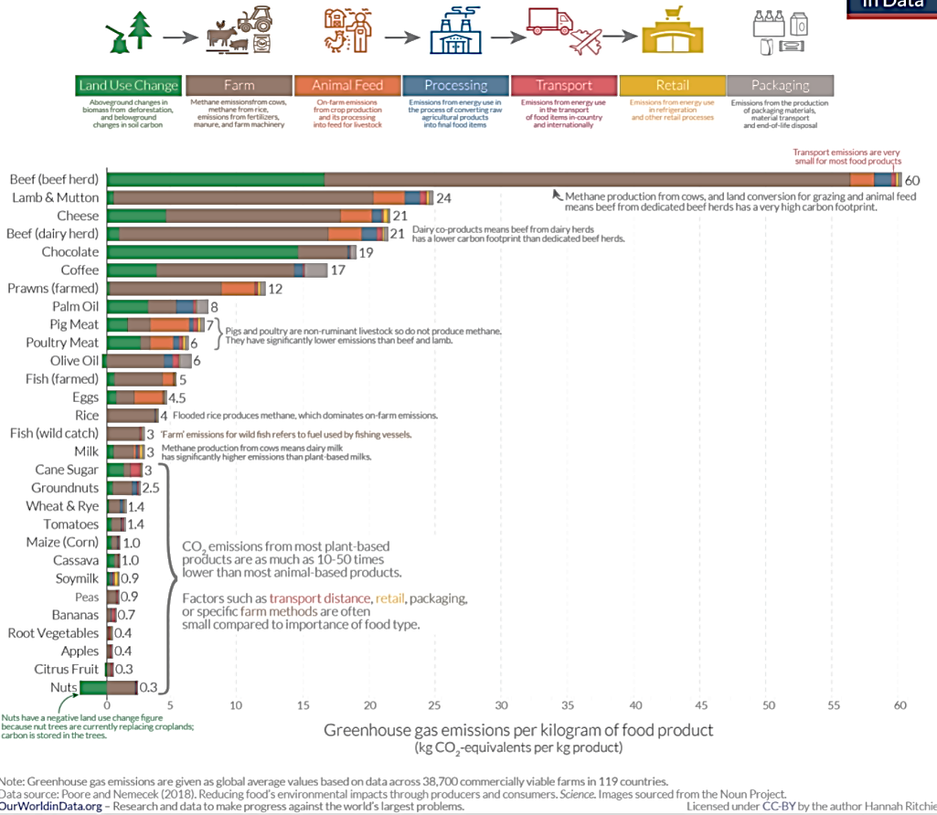
(https://ourworldindata.org/environmental-impacts-of-food#carbon-footprint-of-food-products)

Question 12 introduces the striking finding that roughly a quarter of the food that is produced globally is not eaten by people. Food waste “refers to food that is of good quality and fit for human consumption but that does not get consumed because it is discarded – either before or after it spoils. Food waste is the result of negligence or conscious decision to throw food away.” (https://www.wri.org/research/reducing-food-loss-and-waste) Food loss refers to unintended processes such as spilling during harvesting and processing or consumption by rodents and other pests. Food loss is more of a problem in low-income countries, whereas food waste is more of a problem in high-income countries.

It has been estimated that, globally, food waste and food loss are responsible for roughly 6% of total greenhouse gas emissions (https://ourworldindata.org/food-waste-emissions). Food waste and food loss results in increased greenhouse gas emissions because of the need to produce more food (with the resulting additional greenhouse gas emissions) and the production of methane when food waste rots in landfills. The contrast between each minor individual incident of food waste and their cumulative significant global impact provides an opportunity to discuss the Crosscutting Concept, “The significance of a phenomenon is dependent on the scale, proportion, and quantity at which it occurs.”

You may want to show your students the 3-minute video “How Your Sandwich Changed the World” (https://www.npr.org/sections/thesalt/2017/06/20/533128467/how-your-sandwich-changed-the-world ). This video provides a general review of the contributions of food production to greenhouse gases and global warming. To avoid confusion, you should explain that when the narrator refers to CO₂, he often means CO₂ equivalents.

How can we feed the growing world population without increasing global warming? – Instructional Suggestions
Even if you do not have time for your students to prepare reports, I recommend inclusion of at least question 13 and a discussion of possible strategies to reduce the amount of greenhouse gases released during food production. This will begin to answer one of the guiding questions for this activity, “How can we feed the growing world population without increasing global warming?” This discussion will also serve as an important antidote to hopelessness and other negative emotions that can easily arise when studying a problem like climate change.

Question 13 suggests that students refer to the previous sections of the Student Handout and to the Reliable Relevant Sources for ideas about possible strategies to propose. Utilization of the listed sources will have the advantage that students will be able to research their proposed strategies using vetted resources. You may want to ensure that your students will be able to access these websites through your school Internet service. Alternatively, you could provide printed copies of these sources. If you allow your students to use sources other than the recommended Reliable Relevant Sources, you will probably want to discuss criteria for evaluating Internet sources or refer your students to Internet sources such as https://www.library.georgetown.edu/tutorials/research-guides/evaluating-internet-content, https://www.smu.ca/academics/evaluating-internet-resources.html and https://bit.ly/3t6nWDY).

If you prefer a more open-ended version of question 14, you can use the following.

14. How should we evaluate the advantages and disadvantages of proposed strategies to reduce the amount of greenhouse gases released during future food production? Propose criteria that should be used.

You should have a class discussion of question 14 before your students begin question 15. Remind students that they should think about which information in the source articles is relevant for improving and/or evaluating their proposal to reduce the amount of greenhouse gases released by future food production. They should not include in their reports information that is not relevant for these purposes.

Question 15 leaves the format of the student reports up to you. You may want to focus on one of the sections in the “Reliable Relevant Sources” and use this jigsaw approach.
- Tell your class that they will read one article in their small group, summarize the main conclusions and evidence, and then share this information with a group of students who have read other articles.
- As students complete the reading individually, each of them should prepare a summary and possibly annotate the article and/or answer any questions that you may have prepared.
- Have students who read the same article briefly share their findings with one another and discuss the article. They should talk through anything that is unclear. This will help students prepare to briefly summarize their article in the mixed group.
- Regroup students so that one representative from each article is in each group. Ask students to briefly summarize their articles in their new groups. When sharing the summaries, students should make connections to what they have heard in the other students’ summaries. They should talk through anything that seems inconsistent from one article to the next. Students should take notes during this sharing, listening, and discussion process.
- The whole class then discusses the main takeaways from the jigsaw reading. Ask students what questions they are still wondering about and try to follow up.

Another approach would be to have different student groups present their findings on each approach suggested in one of the sections of the “Reliable Relevant Sources”. (You may want to have two groups cooperate to report on each of the first two topics in Reliable Relevant Sources, since these topics have about twice as many sources listed as the other topics.) Then you can have a class discussion on the advantages and disadvantages of the various proposals to reduce the contribution of future food production to global warming and climate change. If you plan to do this and you don’t already have a format for student presentations, you may find the following suggestions helpful.
- Be clear about what students should include in their presentation.
- Set a time limit for each presentation.
- Students should prepare a poster or 1-3 slides with a few major points written in large enough letters so everyone will be able to read them. If graphics are included, they should be relevant, clear and large enough for everyone to see.
- Students should prepare a script and rehearse their presentation.
- If you can, review the material that students have prepared before their class presentation.

If your students are preparing written reports, you may want to remind them of the following:
- If you allow a few quotations, these should be given in quotation marks with a specific citation. With the exception of explicit quotations, the reports should be written entirely in the student’s own words! To accomplish this, it is helpful for the student to put the source articles aside while drafting his or her report and then later use the original sources to check accuracy, as needed.
- Students should include at least one reference for each major assertion in the report.

For any of these types of reports, you may want to remind students of the CER = claim, evidence, reasoning format for a scientific argument (https://beakersandink.com/how-to-teach-claims-evidence-and-reasoning-cer-like-a-pro/).

How can we feed the growing world population without increasing global warming? – Background Information
Even if fossil fuel emissions were eliminated immediately, current trends in agriculture, food consumption, and population growth would make it very unlikely that we would meet the greenhouse gas emission targets to avoid irreversible damage to the earth as a result of global warming and climate change (https://theconversation.com/global-food-system-emissions-alone-threaten-warming-beyond-1-5-c-but-we-can-act-now-to-stop-it-149312; https://science.sciencemag.org/content/370/6517/705; https://www.nature.com/articles/nclimate2353).

The figure below shows how much the world population has grown in recent decades and is expected to grow through 2100.
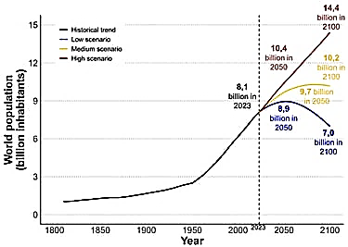
(https://assets.zyrosite.com/cdn-cgi/image/format=auto,w=375,h=267,fit=crop/YX4WX9LbbotOrKEg/graphique_projections_ajouts_en-Yg2q9nK6Q5t2wbGJ.jpg)

In recent decades, meat and dairy consumption per capita has increased as incomes have increased (see table and figure below). Notice that the levels of meat and dairy consumption are still much lower in developing countries than the levels in developed countries.

Per capita Food Consumption
 | Developing Countries |  |  | Developed Countries
 | 1969-1971 | 2005-2007 |  | 1969-1971 | 2005-2007
Meat (carcass weight;  kilograms/person/year) | 11 | 28 |  | 63 | 80
Milk and dairy (excluding butter;  kilograms fresh milk  equivalent/person/year) | 29 | 52 |  | 189 | 202
(Source of data: Annual Review of Environment and Resources, 2015, 40:177-202)

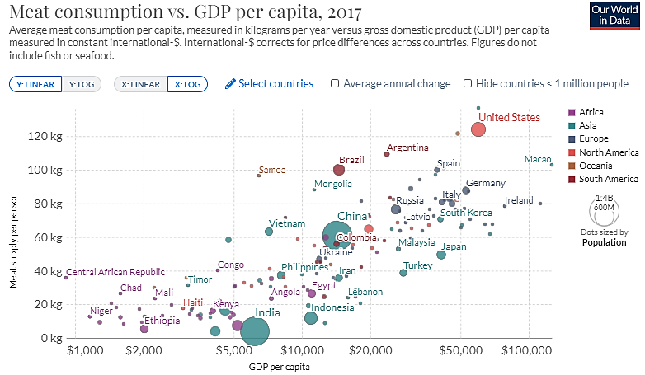
(https://ourworldindata.org/meat-production)

As background for identifying strategies to reduce the amount of greenhouse gas emissions from future food production, it is helpful to consider estimates of the relative importance of the various current components (see table below).

Global Greenhouse Gas Emissions from Food Production
 | Percent of total food production emissions
Livestock and fisheries (methane from ruminant digestion, emissions from manure and pasture management) | 31%
Crop production (for human food and for animal feed) | 27%
Land-use change (e.g., clearing and burning forests for pasture and cropland) | 24%
Transport | 6%*
Packaging | 5%
Food processing | 4%
Retail | 3%
(https://ourworldindata.org/environmental-impacts-of-food)
*This appears to be a significant underestimate of the contribution of transport to greenhouse gas emissions from food production (Nature Food 3:445-453, 2022).

A useful overview of multiple ways to reduce greenhouse gas emissions associated with food production is available at https://www.wri.org/blog/2018/12/how-sustainably-feed-10-billion-people-2050-21-charts. If you and/or your students are interested in farming, another useful source is https://research.wri.org/wrr-food/course/reduce-greenhouse-gas-emissions-agricultural-production-synthesis.

One analysis (https://science.sciencemag.org/content/370/6517/705) has shown that if greenhouse gas emissions due to fossil fuel combustion declined to zero by 2050, then the following proposed changes in the food system could meet the climate change targets to avoid substantial risk of irreversible harmful effects:
- reducing consumption of animal foods and avoiding overconsumption of calories
- more efficient use of fertilizer and other inputs, improved crop genetics and agronomic practices
- reducing food loss and waste. ,

The results of a related analysis are summarized in the table below. The proposed healthy diet would limit calories to prevent overweight and obesity. The diet “largely consists of vegetables, fruits, whole grains, legumes, nuts, and unsaturated oils; includes a low to moderate amount of seafood and poultry; and includes no or a low quantity of red meat, processed meat, added sugar, refined grains, and starchy vegetables.” The authors estimate that global adoption of this diet would reduce greenhouse gas emissions from the global food system by roughly one half and would provide major health benefits, including a large reduction in total mortality (https://www.thelancet.com/journals/lancet/article/PIIS0140-6736(25)01201-2/abstract).

% Decrease in Greenhouse Gas Emissions from the Global Food System
Compared to Continuing Current Practices, 2050

Proposed Strategy | % Decrease
Adoption of the proposed healthy diet | ~50%
Improved agricultural practices | ~10%
Reducing waste by half | ~7%
All three strategies combined | ~60%

(calculated from data in Figure 6 on page 27 of https://www.thelancet.com/commissions/EAT)

Important criteria for assessing proposed strategies to reduce the release of greenhouse gases include effectiveness, technical feasibility, cost, and whether the proposed strategies would result in harmful and/or beneficial “side effects”. An ideal proposal:
- would be feasible (technically feasible, not too expensive, and people will accept)
- would be effective (quantitatively significant net reduction in greenhouse gas emissions)
- would have no or minimal harmful side effects (e.g., would not result in inadequate nutrition nor use too much water where water is a scarce resource) and, if possible, would have some beneficial side effects.
Examples of potential beneficial side effects include:
- better health associated with plant-based diets
- decreased hunger as a result of decreased food loss
- reduced eutrophication of aquatic ecosystems if excess fertilizer use is avoided by applying optimum amounts at optimum times.
For some proposed strategies, technological advances could change the effectiveness, feasibility, cost and side effects. In addition to technical feasibility, we should consider societal and political feasibility, taking into account that this may change as the effects of climate change become more evident and people become more informed. It should also be mentioned that the optimum version of a strategy is likely to vary in different regions and the relative advantages and disadvantages will probably also vary.

The first section of the “Reliable Relevant Sources” on page 7 of the Student Handout introduces the concept that more plant-based diets will reduce greenhouse gas emissions and will also improve human health. In this same section, reference g proposes a tax on meat as one way to reduce meat consumption. To help students understand the rationale for these taxes, you may want to introduce the idea of an externality; an externality is a consequence of a commercial activity that adversely affects other people, but is not included in the price to the consumer. For example, consumers do not pay for the costs of harm to others caused by greenhouse gas emissions and water pollution due to production of food or other goods. One general approach to the problem of externalities is to use taxes both to offset the cost to society of externalities and to shift people’s behavior away from behaviors that result in externalities and toward behaviors with the maximum benefit for society. Taxes on meat could be viewed as offsetting the cost of greenhouse gas emissions and other environmental problems associated with meat production.

Sources for Student Handout Figures
- Figure of carbon cycle on page 1, modified from https://www.no-tillfarmer.com/ext/resources/images/enewsletters/DNT/2016/11/cattle-grazing-rye-cover-crop-2.jpg?1479760124
- Figure of tractor/farm equipment on page 1 – https://environment.co/wp-content/uploads/sites/4/2020/01/farm_equipment_1578066950-e1578066969987.jpg
- Figure of trophic pyramid for vegetarian vs. carnivorous people on page 2, modified from https://o.quizlet.com/z.wi9Xf8UIuqSTbABNMmIA.png
- Figure of cow on page 3, modified from
http://english.cas.cn/newsroom/research_news/201705/W020170518587070843478.png
Figure of dry vs. flooded rice fields on page 3, modified from https://www.shimadzu.com/an/sites/shimadzu.com.an/files/d7/ckeditor/an/case-studies/change_climate/mechanism_of_greenhouse_gas_emissions_from_agriculture_b.jpg
- Figure of legumes on page 4, modified from https://www.facebook.com/Gkbooks44/posts/%EF%B8%8F-why-legumes-are-called-nitrogen-fixing-plants-legumes-host-rhizobium-bacteria-/1223059999941988/
- Figure of total greenhouse gas emissions for different types of food on page 5, modified from https://ourworldindata.org/environmental-impacts-of-food

By Dr. Ingrid Waldron, Biology Department, Univ. Pennsylvania, © 2026. These Teacher Notes and the Student Handout for this activity are available at https://serendipstudio.org/exchange/bioactivities/FoodClimateChange.
https://www.nextgenscience.org/
Some animals like horses have only one stomach, but they can live on a diet of grass because microorganisms in a large cecum can digest cellulose. A horse produces substantially less methane than a cow.
The figure mentions gram as an example of a legume. This refers primarily to chickpeas (garbanzo beans).
Some fertilizers contain urea which is converted to NH₄⁺ and then to NO₃⁻. Fertilizers also commonly contain phosphate and potassium, which are also often limiting resources for plant growth.
CH₄ and N₂O do not last as long as CO₂ in the atmosphere so, in future centuries, the impact of CH₄ and N₂O released this year will be less relative to the impact of CO₂ released this year.
The rate of greenhouse gas emissions for farmed prawns (shrimp) is high in large part because of the destruction of mangrove trees in coastal areas to make room for prawn farms. The greenhouse gas emission rates for nuts are particularly low because growing nut trees absorb CO₂.
The distinction between food waste and food loss is not made in the Student Handout; these two categories are combined under the general heading of food waste.
These instructions are adapted from https://www.nsta.org/science-teacher/science-teacher-march-2020/novel-coronavirus. Other instructions for jigsaw activities are available at https://www.jigsaw.org/ and https://www.schreyerinstitute.psu.edu/pdf/alex/jigsaw.pdf.
For additional non-food-related actions that students can take to reduce global warming, see pages 8-9 in the Teacher Notes for "Introduction to Global Warming" (https://serendipstudio.org/exchange/bioactivities/IntroGlobalWarming).
In discussing solutions to global warming-related problems, it can be useful to distinguish between mitigation and adaptation. Mitigation refers to “reducing the amount and speed of future climate change by reducing emissions of heat-trapping gases or removing carbon dioxide from the atmosphere.” Adaptation “refers to actions to prepare for and adjust to new conditions, thereby reducing harm or taking advantage of new opportunities. Mitigation and adaptation actions are linked in multiple ways, including that effective mitigation reduces the need for adaptation in the future. Both are essential parts of a comprehensive climate change response strategy. The threat of irreversible impacts makes the timing of mitigation efforts particularly critical.” (http://nca2014.globalchange.gov/highlights/overview/overview#intro-section-2). This learning activity focuses on one aspect of mitigation and does not discuss adaptation, although adaptation will also be needed. An introduction to adaptation and mitigation in agriculture is available at https://csa.guide/csa/what-is-climate-smart-agriculture.
The predicted improvements in health and environmental impacts are unlikely if people switch from meat consumption to “ultra-processed” foods (or “junk foods”) (https://www.thelancet.com/journals/lanplh/article/PIIS2542-5196(21)00254-0/fulltext; https://www.sciencedirect.com/science/article/pii/S0921800916303615; https://www.mdpi.com/2072-6643/12/7/1955). Unfortunately, the US government currently subsidizes the production of several commodities that are often used to produce “junk food” (https://www.americanactionforum.org/research/primer-agriculture-subsidies-and-their-influence-on-the-composition-of-u-s-food-supply-and-consumption/).

