Soap Opera Genetics – Genetics to Resolve Real-Life Dilemmas

How can our baby be albino?

Tiffany and Joe are surprised to learn that their new baby has albinism, with very pale skin and hair color. Tiffany‘s sister has come to visit her, so Joe goes out to talk with his sister, Vicky.

Did Tiffany have an affair?
Joe is very angry. He tells Vicky, "I think Tiffany had an affair with Sam! He’s the only albino we know. Obviously, Tiffany and I aren't albino, so Sam must be the father."

Luckily, Vicky remembers her high school biology. She explains, “Two parents with normal skin and hair color can have an albino baby if both of them are heterozygous and have a recessive allele for albinism.”

Joe exclaims, “You aren’t even speaking English! What do those words even mean?”

1. To help Joe understand, explain the meaning of “heterozygous” and “recessive allele”.

Once Joe understands these explanations, he asks, “So how do two parents who are not albino have a baby who is albino?” Vicky begins her answer by introducing these symbols:
A = the dominant allele; a person who has the AA or Aa genotype has normal skin and
hair color; the A allele gives the instructions for making the enzyme that makes melanin, the pigment that gives color to skin and hair
a = the recessive allele; a person who has the aa genotype will have albinism, with very pale skin and hair; the a allele gives the instructions for making a non-functional enzyme that cannot make melanin; the a allele is recessive because even one copy of the A allele codes for enough functional enzyme to make enough melanin to result in normal skin and hair color.

2a. Vicky explains that “Each heterozygous parent has the _______ genotype, so they will have
(AA / Aa / aa)
normal skin and hair coloring. Meiosis in a heterozygous parent can make eggs or sperm that have the A allele or the a allele.”

2b. Joe interrupts to ask, “What is meiosis?” Answer his question.

3a. Vicki continues, “If an egg with the a allele is fertilized by a sperm with the a allele, then the

zygote will have the _______ genotype, and this zygote will develop into a baby with albinism.”
(AA / Aa / aa)

3b. Joe asks “What is a zygote? How does the zygote develop into a baby with albinism?” Answer Joe’s questions.

4a. Joe asks “So, will all our children be albino?” Draw a Punnett square to answer Joe’s question.
- Put triangles around each symbol that represents the genetic makeup of an egg or sperm.
- Use arrows to illustrate an example of fertilization to produce a zygote.
- Circle the genotypes of any zygotes that would develop into an offspring who would have normal skin and hair coloring.

4b. On average this Punnett square predicts that ______ of all babies born to two heterozygous
(1/4 / 2/4 / 3/4)
(Aa) parents will have albinism.

Why don’t more babies have albinism?
By now, Joe has calmed down and he is getting interested. He asks Vicky, "If that’s how it works, it seems as though a quarter of all babies should be albino. How come there are hardly any albino babies?"

5. What explanation should Vicky give to answer his question?

Joe is starting to feel guilty about getting so mad. He says "Geez, I feel like a jerk. I should have known that Tiffany would never cheat on me." Vicky responds, "That's okay. You were upset. Let's just forget about it."

Will Tiffany and Joe's next baby have albinism?
Two years later, Tiffany is pregnant again. She and Joe are discussing whether their second baby will be albino. Tiffany thinks the baby will probably be albino, but Joe remembers Vicky's explanation, and he tells Tiffany, "No, our second baby can't be albino because only one out of every four of our children should be albino. We already have one albino child, so our next three children should not be albino."

6a. Is Joe right? yes ___ no ___

6b. Explain why Joe’s argument that their second baby can’t be albino is right or wrong.

7a. What is the probability that Tiffany and Joe's second baby will have albinism?

7b. How do you know?

Were the babies switched?

Two couples had babies on the same day in the same hospital.
- Denise and Earnest had a girl, Tonya.
- Danielle and Michael had twins, a boy, Michael, Jr., and a girl, Michelle.

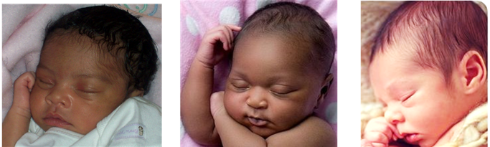
Tonya Michael Jr. Michelle

Danielle was convinced that there had been a mix-up and she had the wrong baby girl. Tonya and Michael Jr. looked more like twins since they both had darker skin, while Michelle had lighter skin.

Danielle also argued that the blood types of the parents and babies proved that there had been a mix-up. She was the only parent with type O blood and Tonya was the only baby with type O blood.

1a. Do you think that the hospital made a mistake?
yes ___ no ___ not enough information to decide ___

1b. Explain your reasoning.

The Genetics of Blood Types
To analyze the blood type evidence, you will need to understand the biology of blood types. Your blood type is determined by whether your red blood cells have type A and/or type B carbohydrate molecules on the surface.

A person with: | has:
type A blood | type A carbohydrate molecules  on the surface of his or her red blood cells | 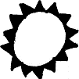
type B blood | type B carbohydrate molecules  on the surface of his or her red blood cells | 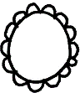
type AB blood | both type A and type B carbohydrate molecules  on the surface of his or her red blood cells | 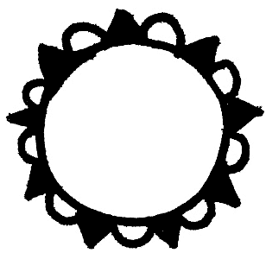
type O blood | neither type A nor type B carbohydrate molecules  on the surface of his or her red blood cells | 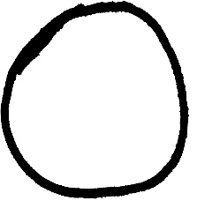

- These four different blood types result from three different alleles of a single gene.
- Each allele gives the directions for making a different version of a protein enzyme that can put carbohydrate molecules on the surface of red blood cells.

Allele* | gives the directions for making a version of the enzyme that:
E^{A} | puts type A carbohydrate molecules on the surface of red blood cells
E^{B} | puts type B carbohydrate molecules on the surface of red blood cells
e | is inactive; does not put either type of carbohydrate molecule  on the surface of red blood cells
*The E in each allele name stands for enzyme.

2. Genes only give the instructions for making proteins. So, how do different alleles of the blood type gene result in different carbohydrates on the surface of red blood cells?

Each person has two copies of the blood type gene, one inherited from his/her mother and the other inherited from his/her father. This table shows some of the possible genotypes and the effects of each genotype.

Genotype | Cells of a person with this genotype make: | Blood Type
E^{A}E^{A} | the version of the enzyme that puts type A carbohydrate molecules on the surface of red blood cells. | A
ee | the inactive protein that does not put either type A or type B carbohydrate molecules on the surface of red blood cells. | O
E^{A}e | both the version of the enzyme that puts type A carbohydrate molecules on the surface of red blood cells and the inactive protein | A

3a. In a person with the E^{A}e genotype, which allele is dominant? E^{A} ___ or e ___
3b. Explain your reasoning. Include a definition of a dominant allele in your answer.

4. For each genotype in the table below, indicate whether the person’s cells would make each type of enzyme and which blood type would result.

Genotype | Will this person's cells make the version of the enzyme that puts this carbohydrate on the surface of his/her red blood cells? | Blood Type
E^{B}E^{B} | type A yes ___ no ___; type B yes ___ no ___;
E^{B}e | type A yes ___ no ___; type B yes ___ no ___;
E^{A}E^{B} | type A yes ___ no ___; type B yes ___ no ___; | AB

Codominance occurs when two alleles of a gene each have a different observable effect on the phenotype of a heterozygous individual. Thus, in codominance, both alleles are dominant.

5a. In the above table, circle the blood type that shows evidence of codominance.
5b. Explain your reasoning.

Were the babies switched?

This figure shows the blood types of the families if the hospital did not make a mistake.  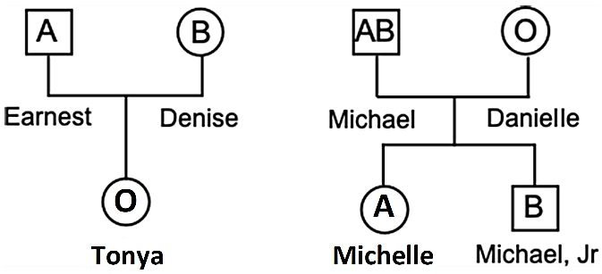 | This figure shows the blood types of the families if the baby girls were accidentally switched.  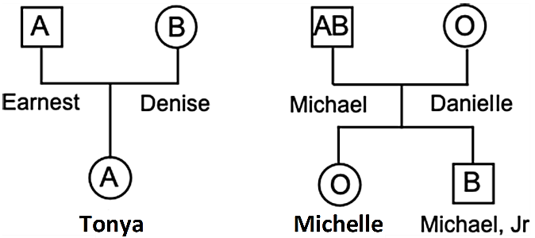

6a. Use the symbols, E^{A}, E^{B}, and e to write the possible genotypes for each parent and baby in the left-hand box above.

6b. Draw a Punnett square for Michael and Danielle. Label the blood type for each potential offspring. | 6c. Draw a Punnett Square to show how Earnest and Denise could have a child with type O blood.

7a. Did the hospital make a mistake? Were the babies switched? yes ___ no ___

7b. How do you know?

Why do the twins look so different?
Now, Danielle wants to know how her twins could look so different, with Michael Jr. having dark skin and Michelle having light skin. First, Danielle needs to understand that there are two types of twins. Identical twins have exactly the same genes, since identical twins originate when a developing embryo splits into two embryos.

8. How do you know that Michelle and Michael Jr. are not identical twins?

Michelle and Michael Jr. are fraternal twins, the result of two different eggs, each fertilized by a different sperm. These different eggs and sperm had different alleles for the genes that influence skin color. So, Michelle and Michael Jr. inherited different alleles for these genes.

To begin to understand how Michelle could have light skin and her twin brother, Michael Jr., could have dark skin, consider the effects of the T and t alleles of one of the genes that
influence skin color. Notice that the heterozygous Tt individual has an intermediate phenotype, halfway between the two homozygous individuals (TT and tt). This is an example of incomplete dominance. | Genotype | Phenotype (skin color)
 | TT | dark brown
 | Tt | light brown
 | tt | tan

Incomplete dominance occurs when the phenotype of a heterozygous individual is intermediate between the phenotypes of the two different types of homozygous individual.

9. Match each item in the list on the left with the best match from the list on the right.

If the phenotype of a heterozygous individual: | then the type of dominance is:
∙ is intermediate between the phenotypes of the two different types of homozygous individuals, ___ | a. a dominant-recessive pair of alleles
∙ is the same as the phenotype of an individual who is homozygous for the dominant allele, ___ | b. codominance
∙ shows distinct observable effects of both alleles, ___ | c. incomplete dominance

10. The parents, Michael and Danielle, both have the Tt genotype and light brown skin. Draw a Punnett square for this couple, and explain how these parents could have two babies with different color skin – one dark brown and the other tan.

Obviously, people have many different skin colors, not just dark brown, light brown, or tan. These varied skin colors result from the effects of multiple alleles of multiple genes, plus environmental factors such as amount of exposure to sunlight. This flowchart summarizes how multiple genetic and environmental factors influence skin color.
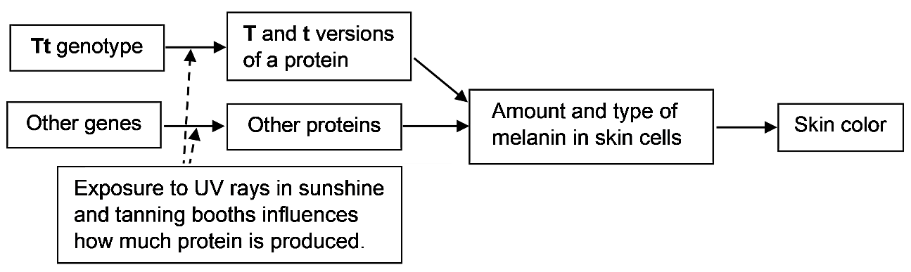

11. This information indicates that the table on the top of this page is oversimplified. Since multiple genetic and environmental factors influence skin color, two people who both have the Tt genotype can have different skin colors. Give two possible reasons why one person with the Tt genotype could have darker skin than another person with the same genotype.

I don't want my children to be color blind like me!

Awilda and Frank at Breakfast
Awilda: Are you sure you want to wear that new shirt to work today? A green and red shirt like that would be better for Christmas, not for St. Patrick's Day.
Frank: Oh no! Not again! I really thought this shirt was just different shades of green. Where's the red?

At Dinner That Night
Frank: I’m worried that the baby we’re expecting will be color blind like me.
Awilda: Remember, the doctor said that he doesn't think that any of our children will be color blind.
Frank: I don't understand his reasoning. I'm color blind, so some of our children will probably be color blind like me.
Awilda: The doctor said that, since no one in my extended family was color blind, I probably don’t have the allele for color blindness, so none of our children will be color blind.
Frank: That doesn't make any sense. How come none of our children will inherit my colorblindness?

To begin her answer to Frank’s question, Awilda explains that the X chromosome has a gene for color vision.
- X_{N} represents an X chromosome with the dominant allele for normal color vision.
- X_{cb} represents an X chromosome with the recessive allele for color blindness.
Because no one in her extended family is colorblind, Awilda believes that her genotype is X_{N}X_{N}.

Answer the following questions to help Awilda explain to Frank why none of their children will be color blind.

1a. The Y chromosome is much smaller than the X chromosome and does not have this gene for color vision. What is Frank’s genotype? X_{cb}Y ___ or X_{N}Y ___

1b. How do you know?

2a. Draw a Punnett square for Frank and Awilda.

2b. What will be the genotype of Frank and Awilda’s daughters?

2c. Why won’t their daughters be color blind?

2d. Why won’t their sons be color blind?

Frank: Okay, I guess I don't have to worry about any of our children being color blind, but what about our grandchildren? Couldn't some of them be color blind?
Awilda: Well, some of our grandchildren could be color blind, especially some of our grandsons.
Frank: I disagree. Girls have more X chromosomes than boys, so girls should be more likely to be color blind.

3. Explain why the risk of color blindness is lower for females (with two X chromosomes) than for males (with only one X chromosome).

Frank: Alright, I understand. My last question is “How could two parents who are not colorblind have a colorblind son like me?”

4a. To answer Frank’s question, first give the genotype of Frank’s father.

4b. How do you know?

4c. What was the genotype of Frank’s mother?

4d. How do you know?

4e. Draw a Punnett square to show how two parents who are not color blind can have a colorblind son. Circle the genotype of the colorblind son.

5. A carrier is someone who does not have a condition (e.g., color blindness), but who can pass the condition on to his or her offspring. Explain why a woman can be a carrier for an X-linked recessive condition like color blindness, but a man cannot be a carrier for this type of condition.

By Dr. Ingrid Waldron, Dept Biology, University of Pennsylvania, © 2026. A Word file for this Student Handout and Teacher Notes with instructional suggestions and biology background are available at https://serendipstudio.org/exchange/bioactivities/SoapOperaGenetics.

