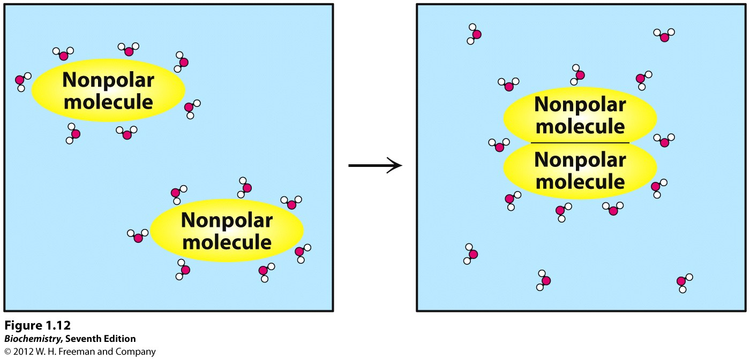 NAME_______________________________ NAME_____________________________

PROTEIN FOLDING—Oct. 2014
Learning Goal—Importance of hydrophobic and hydrophilic amino acids in protein folding.

1. Consider the peptide sequence given below:
Leu-Glu-Glu-Val-Phe-Ser-Gln-Leu-Cys-Thr-H is-Val-Glu-Thr-Leu-Lys

a. For the amino acids above, identify the hydrophobic residues by circling them and the hydrophilic residues by boxing them.

b. Plot the position of each residue of the alpha helix on the helical wheel plot below including the circles and boxes. A helical wheel plot is a two-dimensional plot of the residues of the helix, as viewed along the Z-axis, projected onto the X-Y plane (you are looking down the main helical axis). Hint: How many degrees between consecutive amino acids?

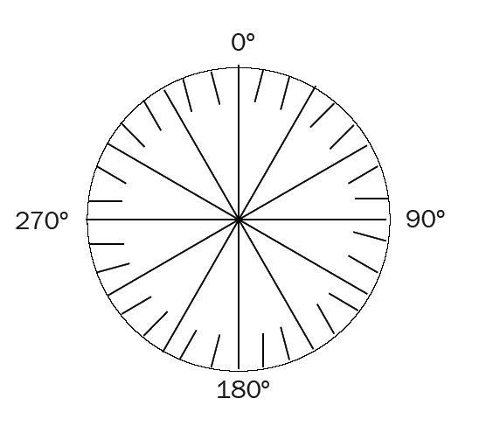
2. Suppose a protein has four helices identical to the alpha helix found in Problem 1 and folds into a “four helix bundle” where the alpha helices are packed together. What part of the helices interact with each other? What force stabilizes this bundle? Draw a the four helix bundle from the top and side

