Evolution by Natural Selection

Part 1 – What is evolution by natural selection?

Mice in a Desert
A population of mice lived in a desert with gray sand. These drawings show how the population changed from Time 1 to Time 3.

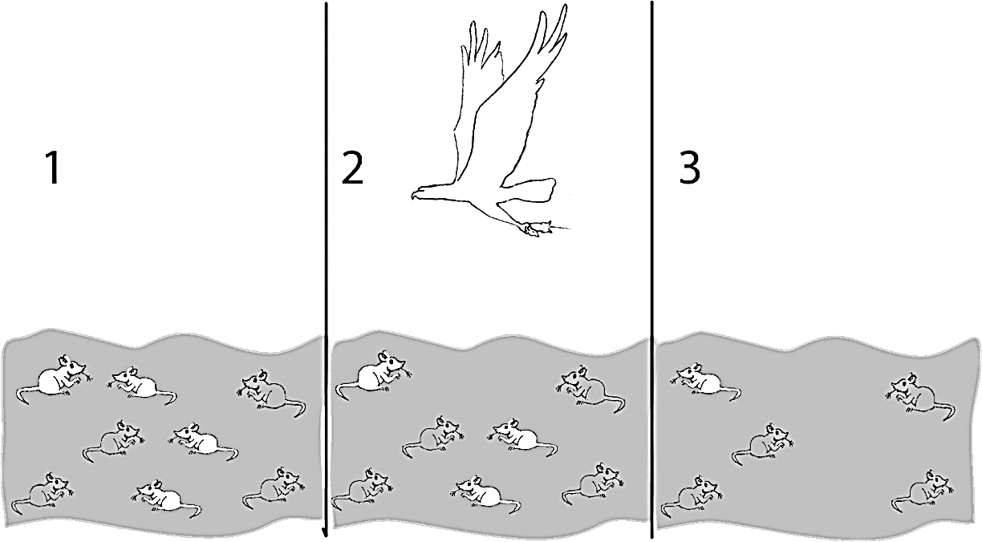

1a. How did the population of mice change from Time 1 to Time 3?

1b. What caused this change?

2. Fitness is defined as the ability to survive and have babies. For the mice in the figure, which characteristic increased fitness?

3. The word “fitness” can mean different things when you are talking about different things.

What does the term physical fitness mean?

What does the term fitness mean when biologists are talking about evolution?

Generations of Mice
- Biologists released three pairs of adult mice in a gray sand desert. These Generation 1 Adults are shown in the first row of this figure.
- These mice had the babies shown in the second row.
- The babies that survived to become the Generation 2 Adults are shown in the last row.
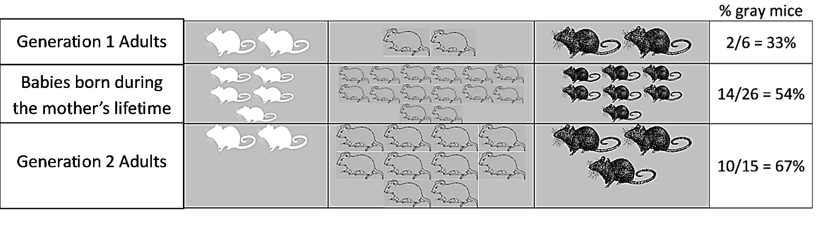
This table shows some characteristics of the Generation 1 adult females.

Color of Fur | White | Gray | Black
Number of babies born | 5 | 14 | 7
Age at death | 3 months | 7 months | 4 months

4. Why do you think the female with gray fur had the most babies? (Hint: Female mice can have a litter every month after they begin having babies at age 2 months.)

- A heritable trait is a characteristic that is influenced by genes and passed from parents to offspring. For example, fur color is a heritable trait for mice.
- An adaptation is a heritable trait that increases fitness (the ability to survive and have babies).

5a. Which color fur is an adaptation for these mice?

5b. What evidence (from the figure at the top of this page) supports your answer?

5c. The percent of adults with gray fur increased from 33% in Generation 1 to 67% in Generation 2. What caused this increase?

6a. Predict what would happen to this population of mice after many generations on the gray sand desert.
- About two-thirds (67%) of the mice would have gray fur.
- Almost all of the mice would have gray fur.
- There would be equal numbers of mice with white fur, gray fur, and black fur.

6b. Explain your reasoning.

Natural Selection
7. Explain how an adaptation becomes common in a population. (Remember that an adaptation is a heritable trait that increases fitness.)

Natural selection causes an adaptation to become common in a population. The adaptation becomes common because:
- Individuals that have this trait live longer and have more babies.
- Their babies generally inherit the same trait.

8a. Natural selection occurs in all types of organisms. What is the adaptation for cacti in the example of natural selection shown in these pictures?

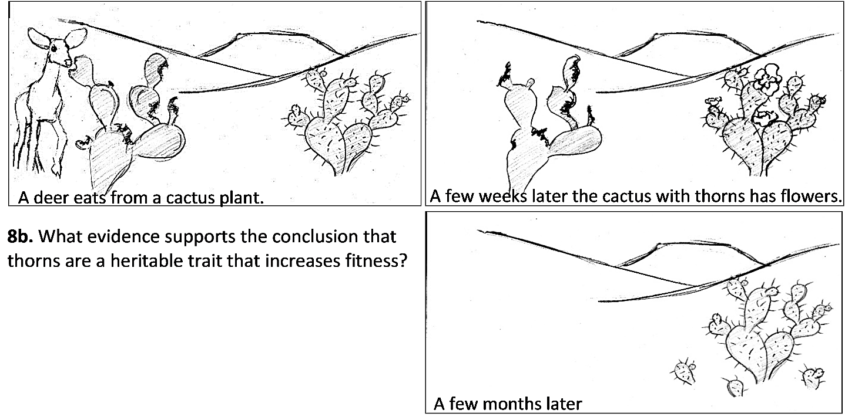

9a. Evolution is defined as a change over time in the inherited characteristics of a population. What is evolution by natural selection? (A complete answer will include adaptation, fitness, and heritable.)

9b. Explain why organisms have many characteristics that help them survive and reproduce in their environment.

10a. Does natural selection produce the same result in different environments? (Hint: Think about mice on gray sand vs. white sand.) yes ___ no ___
10b. Explain your reasoning.

Part 2 – Playing a Game to Model Natural Selection

Now, you will play a game to model natural selection.
- Two habitats: Black Forest and Red Grassland.
- Pom-poms are either red or black.
- Pom-pom color is inherited.
- Hunters (you!) use spoons to catch pom-poms.

11. At the beginning of the game, each pom-pom population will have 50% red pom-poms and 50% black pom-poms. How do you think the percent red vs. black pom-poms will change after you and your classmates have hunted for pom-poms?

On the Black Forest:

On the Red Grassland:

Explain the reasons for your predictions.

Procedure for Game

- Go to your assigned habitat: Black Forest or Red Grassland.

- Rules for Feeding:
- Start and stop when your teacher says to.
- You must pick up each pom-pom with your spoon and drop the pom-pom into your cup. You may not tilt your cup and scoop in pom-poms.
- Once a pom-pom is on a classmate's spoon, it is off limits.

- After feeding, count how many red, black, and total pom-poms you have eaten. Line up with the other hunters in your group. Then, follow the instructions from the Student Helper.

- Your teacher will help the surviving pom-poms to reproduce. Then, you will play the game one more time.

12. Copy the class pom-pom data into the table below. Then, for Generation 2 and Generation 3 in each habitat, calculate the total number of pom-poms and the percent of each color.

 | Pom-poms in the Black Forest |  |  |  | Pom-poms in the Red Grassland
 | Black | Red | Total |  | Black | Red | Total
Generation 1
Number
Percent | 50% | 50% | 100% |  | 50% | 50% | 100%
Generation 2
Number
Percent |  |  | 100% |  |  |  | 100%
Generation 3
Number
Percent |  |  | 100% |  |  |  | 100%

13. Use the data in the table to complete these graphs.

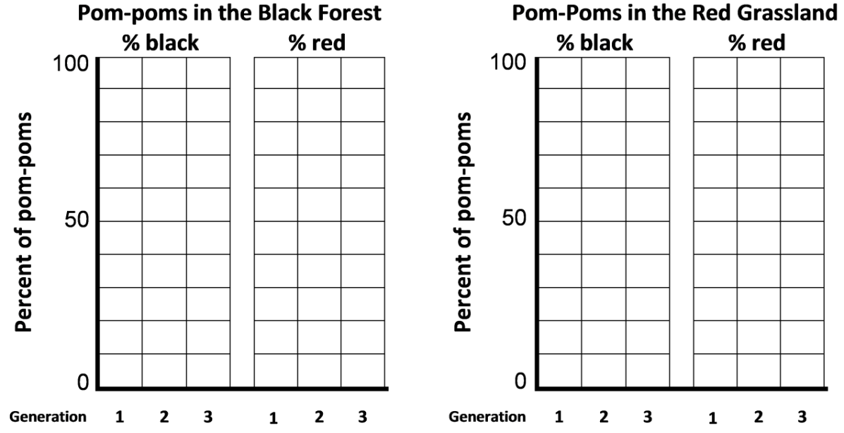

14a. For each habitat, describe the changes in the percent red vs. percent black pom-poms.

Black Forest:

Red Grassland:

14b. Do the results of your game match your predictions in question 11? yes ___ no ___

14c. Explain why the trends were different in the two different habitats.

15a. Did any individual pom-poms change color? yes ___ no ___

15b. If no, then why did the percent red vs. black pom-poms differ between Generation 1 and Generation 3?

Notice that natural selection does not refer to individuals changing their characteristics. Rather, evolution by natural selection results in an adaptation becoming common in a population.

16. This game provides a model that helps us to understand the basic process of natural selection. However, a model simplifies the biological process that it mimics, so there will be differences between the model and the actual biological process. Describe several ways that natural selection in real biological populations differs from our game.

Requirements for Evolution by Natural Selection to Occur
17a. Think about what would happen if your class repeated the game. However, all the pom-poms would be white initially, but half the pom-poms would be dyed red and half the pom-poms would be dyed black. Dyed color would not be heritable. No matter what color the dyed pom-pom parent was, all of its babies would be white. Describe the long-term trends in the populations of baby pom-poms on the two habitats.

Black Forest:

Red Grassland:

17b. Based on this example, explain why evolution by natural selection can only occur if the variation in a trait is heritable.

18a. Suppose that your class repeated the game, but this time all the hunters were blind-folded so they could only find pom-poms by touch. In each habitat, what fraction of the pom-poms would be red at the end of the game? (Remember that at the beginning of the game half the pom-poms were red.)

Black Forest:

Red Grassland:

18b. Explain your reasoning.

18c. Based on this example, explain why evolution by natural selection can only occur if differences in a trait result in differences in fitness.

Part 3 – Natural Selection and the Peppered Moth

Scientists have observed natural selection in action in multiple types of animals, plants and other organisms. We will analyze an example of natural selection in peppered moths.
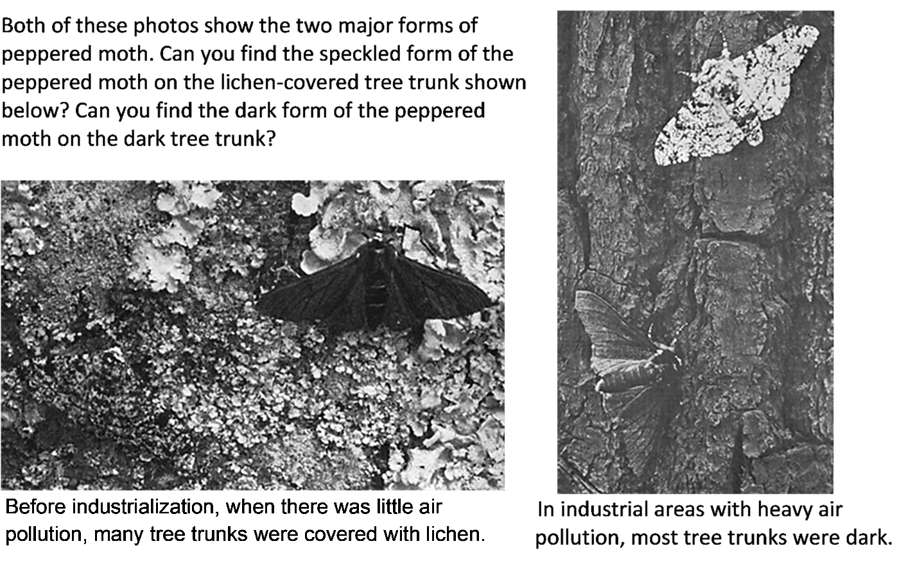
Peppered moths are active at night. During the day, they rest on tree trunks and branches. Some of these resting peppered moths are eaten by birds. Bird predation causes higher mortality for different forms of the peppered moth in each different environment shown above.

19. In each photo, circle the form of the peppered moth that would be more obvious to bird predators and, as a result, would have higher mortality in that environment.

A peppered moth cannot change from speckled to dark or vice versa. The difference between the speckled and dark forms of the peppered moth is heritable (determined by two different versions of a single gene).

20. Complete this table to describe two necessary conditions for evolution by natural selection to occur and the evidence that the peppered moth example fulfills each necessary condition.

Two Necessary Conditions for Evolution by Natural Selection to Occur (Hint: See questions 17b and 18c.) | What is the evidence that the peppered moth  example fulfills each necessary condition?

Industrial Regions in England
This graph shows trends in the percent of peppered moths that were dark in an industrialized
region in England. Each dot in the graph represents a data point. The width of the line indicates uncertainty in the estimates.  21a. Match each description of a historical period with the best match from the list of peppered moth | 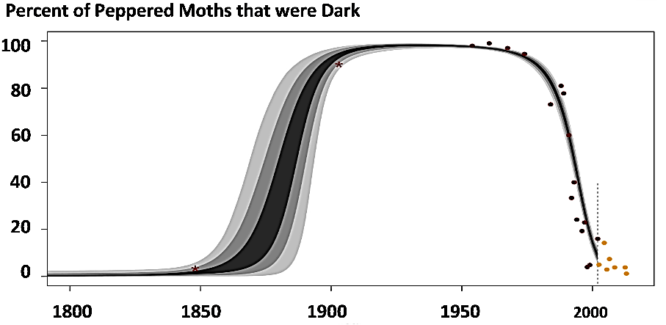
responses.

- Before 1850, air pollution was low and tree trunks and branches were lighter and often covered with lichen. ___
- After 1850, industrialization produced air pollution (including soot); this resulted in dark tree trunks and branches. ___
- Beginning in the late 1950s, government regulation resulted in decreased air pollution, so tree trunks and branches became lighter. ___

- The dark form of the peppered moth became less common.
- The dark form of the peppered moth became more common.
- The dark form of the peppered moth was very rare.

21b. Explain the biological reasons for the changes during industrialization in the percent of peppered moths that were dark.

Rural Regions  22. In this graph, predict the trend in the percent of peppered moths that were dark in rural non-industrial regions. Explain your reasoning. | 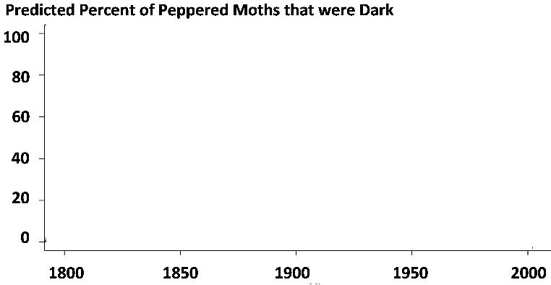

During the second half of the twentieth century, similar trends were observed in industrial regions in England and the US.  Air pollution decreased and the percent of peppered moths that were dark decreased.  In rural regions, air pollution remained low and dark peppered moths were rare throughout this time period. | 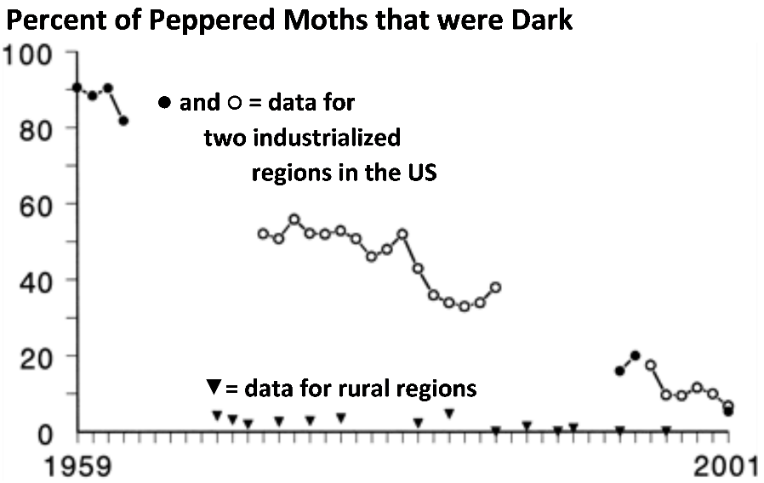

23a. Was natural selection occurring in the rural regions? yes ___ no ___

23b. Explain your reasoning.

General Principles
Scientists have observed multiple additional examples of natural selection in action. For example, natural selection has increased antibiotic resistance in many types of bacteria, and natural selection has increased resistance to pesticides in many types of insects.

24a. Many people think of evolution as "survival of the fittest". How do you think most people interpret "survival of the fittest"?

24b. How do biologists define fitness?

24c. What are some examples of characteristics that contribute to fitness?

25. Explain how the peppered moth example illustrates the general principle that natural selection acts on individuals, but only populations evolve.

By Drs. Ingrid Waldron and Jennifer Doherty, Biology Dept, University of Pennsylvania. © 2026. This simpler Student Handout (suitable for most middle school students), a more complete Student Handout (suitable for most high school students), and Teacher Preparation Notes (with instructional suggestions and background information) are available at https://serendipstudio.org/exchange/waldron/naturalselection.

